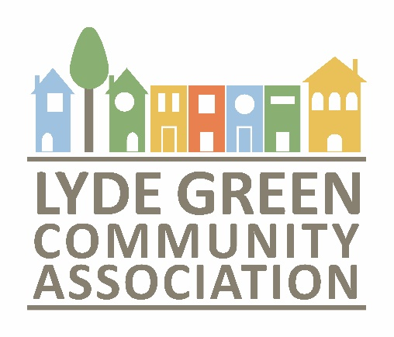

Annual Accounts and Report
1st April 2022 – 31st March 2023

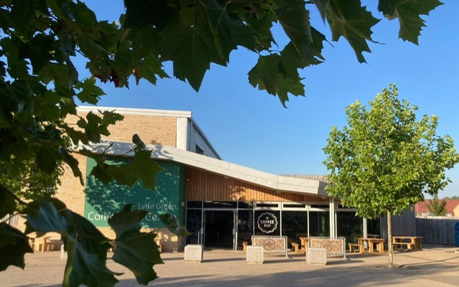

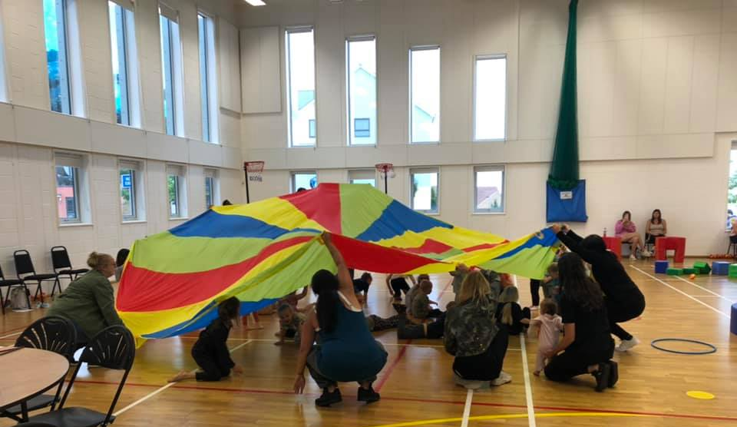

- Legal and Administrative Information

Principal Address
Lyde Green Community Centre, Thistle Close, Bristol BS16 7GW.

Charity Number
1172725

Governing Instrument Charity Commission for England and Wales
Approved Constitution dated 9th January 2017

Bankers
Natwest, Fishponds Bristol Branch

Accounting Services
Jo Trowbridge
Bristol Community Accounting (11836955)

Trustees
Kelly Adams (Chair)
Bob O’Brien (Vice Chair)
Laura O’Brien
Rev. Teresa Taylor
Ed Rosevink
Matt Palmer
Sue Matthews

Employees
Helen Crew – Charity & Centre Manager
Rachel Sheldon- Centre Administrator
Hayley Bigwood – Centre Administrator

Independent Examiner
Geoff Archer

- Introduction
This is LGCA’s annual report and accounts following a year of economic recovery. Like many other charities we have continued to feel impacted by the pandemic with some of our regular hirers ceasing trading or changing the way they operate to online sessions. It has been a year where the LGCA has yet again demonstrated its resilience; keeping the Community Centre operational and working to support the Community.

- Objectives and Activities

“Creating our community’s future”.
Over the past year the association has been working hard, running the Community Centre to ensure it serves the community appropriately, arranging events and facilitating the Lyde Green Partnership Group to ensure that our community is represented at every level.
Our strategic aims are:
- To listen to and represent the views and best interests of those living in Lyde Green
- To develop a community spirit and sense of pride across Lyde Green
- To help improve the local area and support its activities for those that live here
- To work together with all local partners for the benefit of Lyde Green residents.

Our business objectives are:

- Building the local community through events
- Strengthening Partnership working
- Setting up and developing Lyde Green’s Community Centre
- Listening to the Community
- Communicating with the Community
- Developing the Association
- Growing the Board of Trustees

We undertake the following activities in pursuit of achieving the aims and objectives outlined above:
- Organising events for the local community to attend
- Quarterly Partnership Meetings and liaison with partners and stakeholders
- Running Lyde Green’s Community Centre
- Offering opportunities for the community to voice their views about life in LG
- Communicating with the Community
- Training and development for staff, volunteers, and Trustees

During our seventh year of operation, and sixth as a charitable incorporated organisation (CIO), we are pleased to say that we continue to make progress across our aims and objectives.
We have summarised this below.
- Achievements and performance
  - Building the Local Community - Events
Our events team of volunteers has worked hard to put on many events which work for our community. Some of these are low-cost family friendly activities that support our aims to make living in Lyde the best it can be. Our events have included soft play sessions, Inflatable fun sessions during School holidays, Christmas Fayres, a Pantomime and a local Brass Band playing carols in School Square while our Café served hot chocolate and festive snacks.
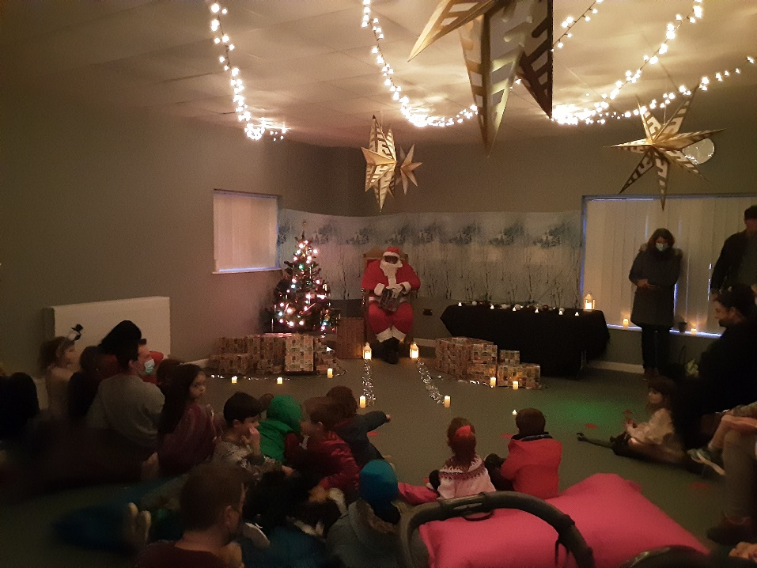

We have worked hard to maintain a strong presence online on our website and on social media platforms to engage and inform the Community.

Partnership Working
We continue to facilitate and be active in a partnership network that are committed to developing Lyde Green as a new community. Partners include representatives from South Gloucestershire Council, Emersons Green Town Council, the Consortium of Developers, Green Square, housing associations, NHS, and the school. This forum has enabled us to put forward residents’ concerns and ask for change.
We continue to work closely with other community groups such as Lyde Green Open Spaces and the Neighbourhood Watch in the interests of building relationships and creating a strong, safe, and pleasant community.
Grant funding has been sought and won to enable several community groups to take place. Downtime is a group that aims to bring the community together by building friendships and contact and preventing social isolation. Lyde Green Book Club has the aim of sharing great books and reading together- this group runs both on social media and in person at the Community Centre. We are also proud to continue to support the STAR (Share Talk and Remember) group offering peer bereavement support. The aim of this group is to create a safe space for people to receive support and to listen to and share stories.

During this financial year our staff team has worked with Neighbourly Collections to pick up surplus food products from local supermarkets. This year alone we have made over 260 collections ensuring that food waste is minimised, and the community can benefit from free items during times of economic worry and easing financial stress.

This year, LGCA has provided hire space free of charge to another charity, Dogs for Good.
This is what they had to say:

“Dogs for Good is a charity that makes life changing differences for people with disabilities through the power of expertly trained dogs and has been fortunate enough to be able to use Lyde Green Community Centre as a base for some of its training. This has included a regular training slot for community dog Pilot who supports people with dementia within the Bristol area as well as a regular training slot for a project that Dogs for Good currently works on with Side by Side. This project enables befrienders and their dogs to go through a six-week training program, after which they will be matched with a person with dementia and will start doing weekly visits.” Julia Winters, Dementia Community Dog Handler.


  - Lyde Green’s Community Centre
Our community centre staff, Trustees and volunteer team have work hard to keep the building running and our doors open. We are grateful for their commitment and willingness to constantly go above and beyond.
Regular activities at the Centre include a large variety of activities with something to suit most ages and abilities.
The classes currently on offer include:
- Pilates and Zumba
- Dance Classes- Jazz, Ballet, Modern, Tap and Acro
- Martial Arts (Judo, Akibudo, Brazilian Ju jitsu and Taekwondo!)
- After Stroke Support
- Children’s Football Teams
- Yoga
- Beavers and Cubs
- Community Learning Sessions
- Healthy Hearts Cardiac Fitness

We also have several baby/toddler classes and groups on a regular basis. These include Music with Mummy, Talking Tots, Sing and Sign, Baby Sensory, Moo Music as well as a parent/Carer play group run by volunteers from St James church called Mango Jams.

We host classes for children who may be temporarily unable to access a mainstream school provision and offer reduced cost hall hire for local home- education groups to allow their children access to sports provision.

We are proud to be part of a diverse community, several religious groups now host their weekly services and meetings at the Centre including Agape Faith, Jesus Nation, and Emerson’s & Lyde Muslim Group.
We also host meetings, conferences, and drop-in sessions from local businesses. The Centre is also available for bookings for parties and events and weekends are most often busy with these types of booking.
Coffee at Lyde, the onsite café, has continued to bring people into the Centre and the café/atrium space is a popular choice for many members of the local community. The LGCA is proud to have supported Coffee at Lyde as a Start-up Business with reduced rent and regular support to ensure that the Café space flourished.
  - Listening to the Community
We aim to always offer a friendly face within the community and listening is a key part of the work we do. Once able, we ran regular drop-in sessions in and around the community centre.
Alongside our more formal listening exercises we have an open-door policy and take every opportunity to talk to members of the local community.
We are working hard to improve our communication skills, enrolling all staff on British Sign Language classes with the goal of being able to communicate with the community in different ways.
  - Communicating with the Community
We have continued to communicate using our monthly column in the local free newspaper (Emerson’s Green Voice) and offer as many updates as we can using our social media platforms, the Community Notice board outside the Centre and our website.
The Community Centre has been a fantastic method of sharing with the community what is happening in the local area. We have many notice boards packed with events and activities. We also promote local consultations and requests from the Council to encourage residents to have a stronger voice in the community.

  - Developing the Association
Across the course of the year, we have used our meetings to share knowledge and experience. We propose that over the coming year we will introduce a formal training budget and provide further opportunities for development for staff, volunteers, and trustees.

  - Growing the Board of Trustees
We have recruited new volunteers across the year and plan to continue this work in the coming year. It is important to keep refreshing those involved where we can to gain new perspectives and alternative views on the work we do. Our aim is to encourage members of our community to join our Board of Trustees.

Summary of public benefits
In undertaking our work throughout the year, we have had regard to the Charities Commission Guidance on Public Benefit including the guidance 'public benefit: running a charity (PB2)'.
In summary the LGCA has provided a number of benefits to those within our area of responsibility and, indeed, many outside of the immediate area. We provide opportunities for members of the community to meet others in the area, thus avoiding the potential pitfalls of social isolation. We offer a variety of events and services through the Community Centre and provide key information about the local area. Our partnership work aims to provide an opportunity for many to voice their thoughts and for those in positions of responsibility to be held to account. As a whole, the work of the LGCA contributes to making Lyde Green a great place to live with a strong sense of place and community.

- Financial Review
At 31 March 2023, the charity had unrestricted funds of £73,750 and restricted funds of £5,129. (to be checked with Jo)
The Trustees are pleased that the level of reserves has been maintained from 2021-2022.

Reserves Policy and Risk Management
Given the large liability of running the Community Centre, the Trustees are working towards having a consistent level of reserves that equates to at least nine months of running costs. The continued impact of the pandemic has highlighted the need for a reserves policy that covers many eventualities, and the reserves present at the end of the financial year have allowed the Trustees to confidently recruit a new team to continue and expand the work of the charity whilst hirer income is uncertain.
A separate sinking fund is in place, as required by our current lease agreement with the Council, to ensure that there are funds available for any unintended major building repairs.

Going concern
The trustees have reviewed the circumstances of the charity and consider that adequate resources continue to be available to fund the activities of the organisation for the foreseeable future. The trustees are therefore of the view that the charity is a going concern.

- Structure, Governance and Management
Governance
The LGCA is a Charitable Incorporated Organisation (CIO) and is governed by a constitution which is available to view in full on our website.
We are committed to improving year on year and we intend to begin working with a local partner Charity to improve our Governance, Constitution and Policies in line with best practice.

The Board of Trustees

Honorary Officials following our AGM in November 2022:
Kelly Adams | Chairperson | Remained in post
Robert O’Brien | Vice-Chair | Remained in post
Vacant | Treasurer
Vacant | Secretary

Trustees following our AGM in November 2022:
Kelly Adams | Remained in post
Robert O’Brien | Remained in post
Sue Matthews | Re-elected
Laura O’Brien | Re-elected
Teresa Taylor | Remained in post
Matt Palmer | Re-elected
Ed Rosevink | Remained in post

Our Chairperson and Vice-Chair are required to be voted in by the new trustees at the first committee meeting following the AGM. We are pleased that both Kelly Adams as Chairperson and Robert O’Brien as Vice-Chair remained in post. Together they have shown themselves to be a strong team lead for the board of Trustees. Despite continued concerted efforts to fill the post our Treasurer role remains vacant, we will continue to work towards filling this post and recruiting to the Trustee team to ensure that the board of Trustees remains engaged, passionate, and committed to the Charity’s works.

Employed staff
The LGCA currently employ a Charity & Centre Manager and a two Community Centre Assistants.

Related parties
The trustees consider that there are no related parties to the charity.

Message from Chair
To follow

