Minutes of the 2022 Annual Parish Assembly of the Parish Council held on Monday 16 May
at 7pm at Blunsdon Village Hall.

Present: Cllrs Jankinson, Banda, Keates, Nash, Selwood & Tayler. PCSO Emma Harriman.
Tracey Judd Parish (Clerk) & Rachel Smith (RFO)
8 members of the public.

1. INTRODUCTIONS
Chair asked for introductions from around the room.
2. APOLOGIES FOR ABSENCE
Cllrs Ainscow, Doell & Rogers. SBC Cllrs Manro & Weisinger.

3. MINUTES OF THE 2021 APA
Proposed by Cllr Nash and seconded by Cllr Selwood that they be accepted as a true record.

4. MATTERS ARISING FROM THE MINUTES
None.

5. REPORT OF THE PC CHAIRMAN
The Chair gave an overview of his report, full report attached.
The Chair thanked the Community Speedwatch Team for their hard work, more volunteers
are always welcome. Thanks, was also expressed to the Chair of the NHP Team, Trevor Morton
Holmes, the Plan is now in place and is actively being used when Planning Apps considered.
Q. Are the Tennis Courts being refurbished as new Tennis Courts?
A. No, the area will be a MUGA (Multi Use Games Area) used by the school during the day and
the Community at other times.

6. OTHER REPORTS
The Chair gave an overview of all the other reports, full reports for Finance, Grounds
Maintenance, Recreation Ground, BVH & Cemetery and Footpaths attached.
Q. Where is Linley Road?
A. Chair gave directions to explain.
The PCSO gave an update on Police activity in Blunsdon over the last year. Full report attached.

Q. Speeding on Ermin Street has increased since the removal of speed humps. The PC is very
concerned about this and has raised this several times with SBC and the Ward Cllrs. Is there
anything the Police can do?
- Advised to copy Penny Sprawson in on the email exchanges so where appropriate she can
comment/support the PC.

7. QUESTION TIME

Q. What are the PC reserves and what kind of return is achieved?
A. The RFO responded – the PC is very limited on where and how it can invest but it does get a
Small return on the £80,000 held in reserve. The PC continually looks at where the best deals are
and acts accordingly.

Q. There appears to be a delay in SBC determining Planning Applications?
A. There are 241 dwellings in pending applications. National Highways has serious concerns about
CH junction, their model shows it currently is over capacity. There is a moratorium in place until
developers can demonstrate that their proposals and mitigations are satisfactory. SBC, NH and
Persimmon are working together in respect of the Strategic site, Kingsdown.
The NHP means that a land supply of 3 years is acceptable rather than the usual 5 years – SBC has
recently commented to the PC that it is confident that land supply requirements will be met.
The PC is in regular contact with SBC about the CH traffic issues.

Q. Community Building Car Park, will the gate continue to be locked overnight?
A. The PC will own the building and car park and intends to have the gate removed. This facility
should be available for community use. Parking is a real issue around Blunsdon. No other PC car
park is locked. The gate/locking is a PC issue not a shop issue, as the whole site is owned by PC.

Q. Does the PC expect parking problems to increase in the future?
A. There are good conditions in place for new development in the provision of parking, however
parking on the streets and verges continues to be a problem and will likely worsen given the volume
of new development.

There being no further business the Chair thanked everyone for their attendance and declared the
meeting closed.

Signed 20 April 2023

Chairman

APA 2022 REPORTS

Chairman’s Report May 2022
I would like to thank my fellow Parish Councillors for their contributions and commitment during what has been a very difficult year. Tracey Judd our Parish Clerk and Rachel Smith our Finance Officer have kept our administration going during that time and Paul Scofield and Mark Jones our groundsmen have kept the village spaces clean and tidy along with our Grounds Maintenance contractor Allbuild.
I cannot review the year without referencing the effect that Covid 19 has had upon the Parish. Although 2021 has been a year of more ‘control’ of the disease with the excellent strategy of vaccinations and medication, it has still had a profound effect on everything we have done.
Like businesses did we stuck with hybrid zoom meetings, despite the legislation not supporting this to ensure healthy, on-line debate and legal face-to-face voting. Despite the new variant threatening to slow it down the easing to Stage 3 restrictions went ahead in May. However, in June the discovery of the Delta variant led to a 4-week delay. Other disappointments were England losing to Italy on penalties in the Euros and that Matt Hancock kiss!
In July the easing happened as schools broke up for summer and Blunsdon won the first stage of the Wiltshire Best Kept Village competition. Also, it was announced that there would be boosters in Sept for the older and more vulnerable among us. The Borough also offered us ‘Trees for Climate’ an initiative set up by Rishi Sunak to plant more trees to help improve the carbon capture – we haven’t seen any of these trees yet, but we are still hoping.
September starts brightly with Emma Raducanu winning the US Open. That is soon forgotten as gas prices begin to rise and there is a spate of panic buying of petrol as that price rises too. The rise of infections of the very transmissible Delta variant, led to shortages of staff and we moved to longer recycling times locally. However, some good news was that we came 3rd overall in the Best Kept Village competition – well done to you all. We also worked with St Leonard’s Church to improve the Churchyard path, sharing the cost to improve the gradient and surface.
During October we discovered that over 40,000 false negative tests caused huge increases in infections locally, but the miraculous NHS delivered 325,000 boosters on one Saturday alone to help defeat the spread of Covid. We did manage to celebrate the outstanding contribution of Stuart Boyd to the PC over 23 years. Amazing dedication, thank you Stuart.
In what was a warm November the new and very transmissible variant, omicron arrives in the UK and will lead to the highest levels of infection across the country. The PC ploughs on and begins to develop the budget for this year. We needed to add in some of the shortfall from the year before but were focussed on ensuring that the Precept would be as close to no increase as possible. We found reserves to replace the Village Hall boiler and to fund the addition of a canopy to the rear of the new community building for the Village Shop to take over.
The Country moved to ‘plan B’ because of the levels of infection, however the variant turned out to be less virulent with gentler symptoms. Christmas came and went, and we celebrated more openly than previously but as the new year dawned, we headed into the start of price rises and annual inflation reached 5.4%, the highest since 1992.
We developed a plan to refurbish the Tennis courts and grassed areas in Linley Road and held an open session to show you what we proposed, and you gave us some positive and useful feedback which we added to the plans which are now with SBC to decide.
In February Russia invades Ukraine and along with the horrific consequences that this brought, the world began to slip into an economic crisis. The gas issue, realised last year, came to a head and a 54% increase in the energy price cap severely affected household bills. Storms ‘Dudley’, ‘Eunice’ and ‘Franklin’ batter us with flooding and landslides and hurricane conditions, and we all look forward to some good news.
The Queen marks 70 years as our Monarch and we look forward to major celebrations later in June. The PC offers to help fund street parties to celebrate and will hold a Jubilee Beacon lighting ceremony to join in with many other Parishes across the country.
The PC links up with St Leonard’s Church to help develop ambitious plans to make the Church into a useable Community Space. We also plan to revive the wild space opposite the Methodist Church and make it into a Community Allotment for the public to use as a ‘resting’ space and a productive space. We hope to plant trees there to replace those that we were forced to remove in the Recreation Ground.
The PC make available new allotments for the Parish and finally open a new Play area in Broad Blunsdon Heights once the safety checks are complete.
Here we are again in May heading again into the Best Kept Village Competition where we hope to improve on our 3rd place last year. In this year’s Annual Parish Assembly, we look forward to a better year and hope the price squeeze doesn’t affect us all too much.
During the year we considered 62 Planning applications, ranging from a 1650 house urban extension in Kingsdown to a new fence along a back garden. A detailed discussion and even more detailed comments to either support or object to each of those applications is reported to the Planning Department.
We have negotiated the grounds maintenance contract for the year to be maintained at same cost as last year. We have looked at every expense closely and found ways to reduce costs even further. Our biggest cost is staffing, and we spend about half our budget on our four very committed and productive people. The GM team cost us around 14% and although the Village Hall costs us about 10% it contributes about 16% to the Precept. Overall, the Parish income provides a quarter of the overall cost to run the Parish.
As the Parish grows our plans must grow with them. We are working hard with the Borough to provide stronger infrastructure and improve the facilities to deal with the growth.
Ian Jankinson – May 2022

Grounds Maintenance:
Blunsdon is a semi-rural village location with a diverse mix of formal and rustic grassed and hedge areas. The PC has defined areas of responsibility to maintain certain grassed and hedged areas, beyond these the Borough Council and Highways England have responsibility (although we monitor and report on any issues as they arise).
Additional substantial hedge work has been complete on the path adjacent to the primary school and at the entrances to the village via High Street & Sams Lane, plus some other locations as required.
The council employs a contractor that completes a pre agreed schedule of works. The schedule is based on a map that was supplied to the PC when services were transferred to the PC. Our financial budgets were based on this projected level of work.
Many of the reactive response issues that we have completed because of resident’s comments etc., are outside of this designated work schedule shown on the map. However, the borough council have limited resources to complete these additional works.
The PC intend to review and update this map, prior to the next tendering of the contractor provide services, due in 2023.
The PC are aware of our environmental responsibilities and will consider a more balanced approach for some areas in terms of less grass mowing etc.to enhance habits.
The PC will continue to monitor our contractors to help ensure we provide a tidy & green village and provide best value within the financial budgets set. Additional projects will be considered to enhance the village further, where the budget allows.
Recreation Ground
The PC has worked with the Football and Cricket Clubs during the year to manage their requirements, and any issues as they arise.
The Parish has benefited from the active involvement of the FC & CC, in maintaining the pitches to their required standards.
A number of mature trees needed to be removed from the edge of REC field, due to an insurance claim being made. The PC plans to replace these trees x2 at different locations.
It is noted that despite additional measures being implemented by the clubs, parking in Sutton Park has continued to have some issues for busier fixtures. The PC are anticipating this situation should be helped by additional parking spaces pending at the new community shop area, and at Linley Road (ref MUGA) when the current schemes development plans are completed.

BVH & Cemetery

The PC has continued to manage the village hall and are pleased to report use levels have increased as the pandemic has changed to a different phase.
The aged and inefficient central heating and water boiler was replaced during the year.
We would like to thank our staff who had a considerable number of additional requirements to implement during the pandemic, to keep the facility clean and safe.
The PC has continued to manage and maintain the village cemetery.
There is an extension to the burial area now pending, as part of the adjacent Hayfield housing development. We are consulting on the boundary wall and preparing to incorporate this area as we enter the next year.
Tree survey works are also pending.
Footpaths
The PC does not have direct responsibility for footpath maintenance, this remains with the Borough Council.
We do understand the importance of our many footpaths to residents and continue to monitor and report on issues as they arise.
Councillor Ian Selwood
May 2022
BLUNSDON PARISH COUNCIL - ANNUAL PARISH ASSEMBLY 2022
FINANCIAL REPORT
2021/22
 | INCOME |  | EXPENDITURE
 | £ |  | £
General Reserves brought forward | 80,947
Precept | 84,850 |  | 0
Community Tax Grant | 1,779 |  | 0
Community Infrastructure Levy | 36,136 |  | 0
Burial Ground | 5,503 |  | 15,021
Recreation Areas | 635 |  | 14,255
Pavilion | 1,160 |  | 3,253
Parish Open Spaces | 0 |  | 12,391
Village Hall | 28,452 |  | 25,526
Allotments | 795 |  | 20
Litter picking | 0 |  | 2,592
General Administration | 0 |  | 7,594
Projects |  |  | 10,473
Staff costs | 0 |  | 53,526
Interest earned | 29 |  | 0
General Reserves carried forward |  |  | 95,635
 | 240,286 |  | 240,286
Reserved funds for specific projects |  |  | 117,536
(eg MUGA, Cemetery extension
works, fitness equipment)
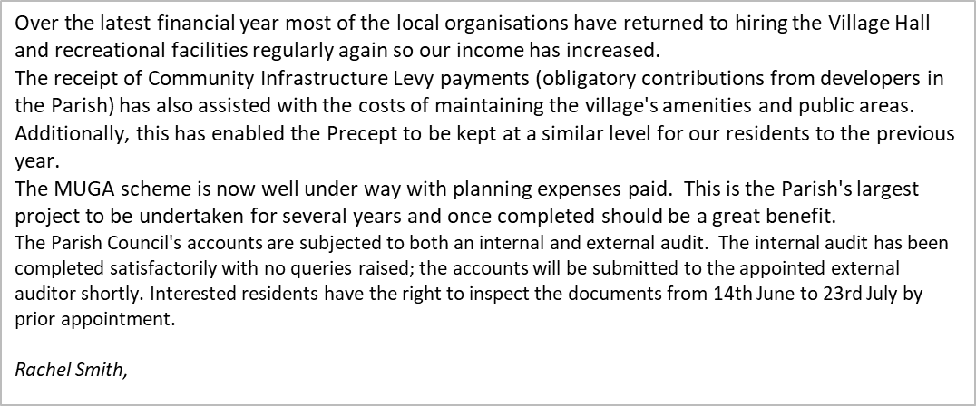

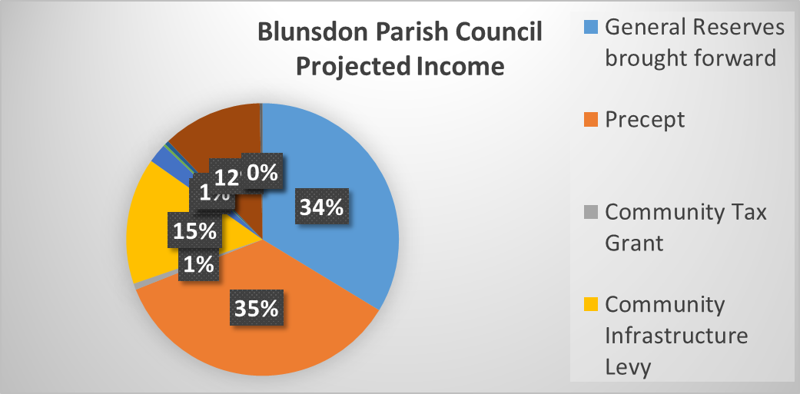
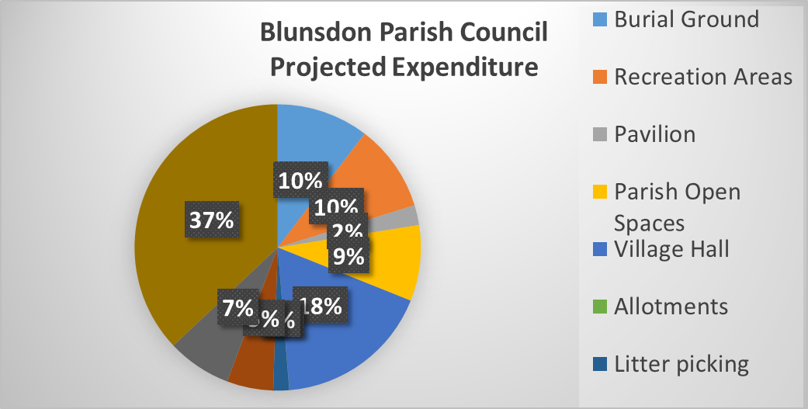

Blunsdon 12 month summary:
100 crimes recorded, 99 non crimes (could be ASB, 3rd party reports etc)
Violence against the person offences (including stalking and harassment) 43 in total. 18 violence without injury, 13 violence resulting in injury and 12 Stalking / harassment offences.
Burglary, 13 in total. Burglary to sheds etc are now recorded as dwelling burglary assuming it is within the curtilage of the property. 10 are business / commercial and 3 are dwelling.
Theft offences 14 total.
Vehicle crime, 5. Of this total, theft of the motor vehicle (1) or theft from it (3) or vehicle interference – trying of door handles / placing items in or on the vehicle (1).

Had a couple of linked building site thefts of scaffolding etc. People have been arrested and are under investigation.

Rural crime trends continue for hare coursing, theft of farm machinery and GPS trackers etc. Nothing specific to Blunsdon but worth mentioning due to the rural nature of the area. We are working with our colleagues in Thames Valley and Gloucestershire Police regarding rural crime trends to identify and target suspects and have recently run a couple of operations overnight with them.

Community Messaging is being pushed again, join up via the Wiltshire Police website, or through the PCCs web page.

Force has a new Speed Enforcement Officer who issues tickets directly to drivers travelling at excess speed, they are then offered points and a fine, a speed awareness course or to go to court depending on the speed. Scott will use the community speedwatch sites to enforce. Two more enforcement officers are being recruited currently.

Emma Harriman

