
Stoke Bliss and Kyre Village Hall

Pub/Social Night

25th April 2025
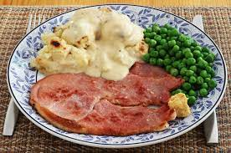 | Ham, Cauliflower Cheese, Potatoes and Peas
Apricot and Almond Cake | 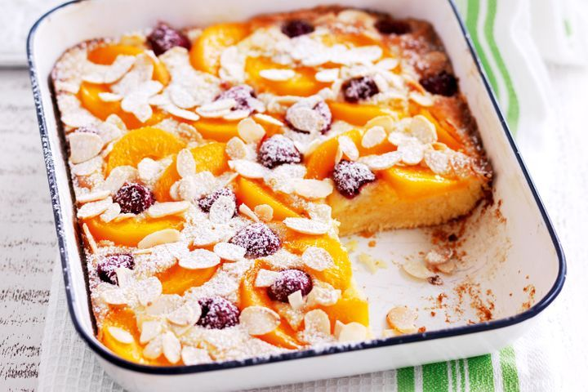
Bar open 7pm Food 8pm

Book your place at SBKVillageHall@gmail.com

