
Maxey Community Association

Saturday 13th December - 2-30-5pm
Children’s Christmas Party
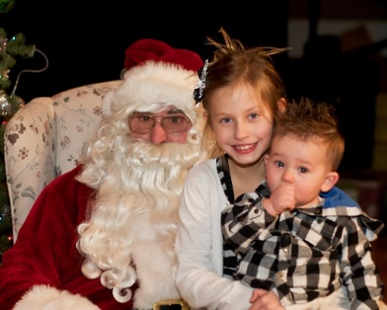
Maxey Village Hall

Party food, magician and of course Father Christmas will be busy with a present for every child. Maxey residents’ children / grandchildren (age 3 – 10) only please. £11 per child. Pre booking only.
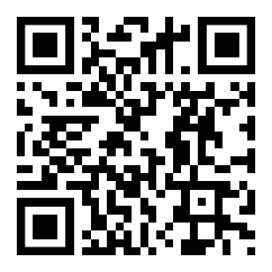
For more information and booking go to the https://maxeyvillagehall.co.uk/ website or scan the QR code.

Any questions or having trouble booking?

Please email: maxeyvillagehall@yahoo.com

