Minutes of the Fourteenth Ordinary meeting of the Parish Council held on Monday 18 November 2024 at 7.30pm. This meeting was held at BVH.

Present: Cllrs Jankinson, (Chair), Hughes, Keates, Poulton, Selwood, Tayler

Apologies: Cllr Compton, Nash & Weston
SBC Cllrs Manro & Weisinger

132. DECLARATIONS OF INTEREST
None.
Recess – One member of the public addressed the PC regarding his planning
application in Chapel Hill. The PC will be consulted once application is processed.
The height and orientation of the property are the key issues.
133. MINUTES FROM THE THIRTEENTH ORDINARY MEETING
Proposed by Cllr Keates, seconded by Cllr Hughes, all agreed they be accepted as a true record. minutes were approved.

134. MATTERS ARISING FROM THE MINUTES
a. Extractor fans and air vents discussed at Rec Committee meeting.
b. Locks for CA have been ordered.
c. Road naming – Bydemill Close rejected by SBC as not unique. Suggested alternatives
considered. Redwood Close selected. Clerk to notify SBC.
d. Xmas tree for BVH ordered delivery early December, date TBC.
e. Operations Manager role advertised locally as agreed.
f. The church pathway cleared of leaves prior to Remembrance Sunday. Thank you to MJ and
the Scouts/Cubs.
g. Tree maintenance plans checked – no action required, review August 2025.

135. FINANCE

- Monthly Accounts - Payments and Receipts were agreed as reported and signed by Cllr Jankinson. Full details attached see Appendix one. The PC approved all reports submitted by RFO.
- Fees & Charges 25/26 – RFO presented a simplified pricing structure. PC approved this approach. Bench marking with other venues to be undertaken. RFO & Cllr Jankinson.
- Draft Budget inclusions 25/26 – Cllr Selwood reported that GM contract would need review considering budget changes to NI and wages. GM contractor to submit report and proposals for meeting on 16 Dec 24. Clerk to add to Agenda.
List of budget priorities to be prepared for discussion at next meeting. RFO to produce summary for discussion.
- NJC Pay award 010424 – PC unanimously approved the implementation of new pay scales. RFO to action in November pay.
Increase for new agreed caretaker role considered – PC unanimously agreed Real Living Wage plus 5%, with effect from 1 Dec 2024. RFO to notify staff and issue new contract.
- Council Allowances – PC agreed to make provision in the budget for any Cllr wishing to claim their allowance. RFO to action.
- RFO report- Fee for Xmas crafties approved by PC. Finance Committee met reviewed funds and reallocated funds to MUGA and Pavilion projects.
RFO reported that there had been unauthorised access and use of BVH. PC agreed no use other than agreed and booked. RFO to contact users.
RFO reported that the budget changes on NI and Minimum wages had little effect on PC.
RFO reported that utility companies were contacting for review and fixing of price. PC agreed to leave until contract ends.
- Email/Web domain – New web now live. Email domain can be progressed, contact to be made with 3 suppliers from the approved register. Clerk to action.

136. PLANNING DECISIONS ADVISED BY SWINDON
None.

137. PLANNING APPLICATIONS DEPOSITED FOR COMMENT

S/HOU/24/1293 - Erection of a two-storey side extension.
At: 29 Ceres Road, Swindon SN26 8AF
PC Agreed to object. Proposals cause overlooking of numbers 27 &28.
Over intensification of the plot and unacceptable change to the street scene.
Other Planning Matters

- MUGA – acoustic fence required, cost £30k. Meeting with Slatters TBA for 25 November.
- Pavilion – Mats and soaps to be ordered from PHS. RFO to action. Storage container to be sourced. Cllr Selwood. Spec for slabs, vents and fans to be agreed. Cllr Tayler. Quotes to be obtained. MJ to action.
- Ermin Street – Urgent meeting requited with SBC. Cllr Watts arranging.
- S/24/0149 – objections from neighbours. To be relisted for PC comments, PC objections remain.

138. CORRESPONDENCE RECEIVED TO 18 NOVEMBER 2024
- NALC Newsletter x2 – emailed to Cllrs.
- NALC CX Bulletin x 2 – emailed to Cllrs.
- SBC Local News & Events x 2 – emailed to Cllrs.
- Chief Constable fortnightly update – emailed to Cllrs.
- SBC Highway News – emailed to Cllrs.
- Street Naming – Redwood Close agreed.
- WALC Newsletter – emailed to Cllrs.
- SBC Media release – culture change – emailed to Cllrs.
- Email – Julias House Xmas Carols – emailed to Cllrs.
- Email – invite to Enterprise Works open day – emailed to Cllrs.
- Email from resident re REC hedge – Clerk responded.
- Resident comments re Solar farm at Rose Lane – forwarded to SBC.
- Emails re S/24/0149 objections, with Ward Cllrs – no recent consultation received by PC.

139. COMMITTEE REPORTS.
- GM – meeting arranged for 10 December. Revision proposals to be provided for discussion by PC on 16 December. GM invoices now better presented. Additional areas for leaf collection added to GM contract. Leaves in cemetery to be cleared and last cut of season if required. Clerk to obtain costs from GM.
- Recreation – Minutes from REC Committee meeting circulated.
- BVH – New pricing structure agreed for next year. Hopefully will make online bookings easier.
- Community Building – VSC committee meeting Cllr Keates reported that she was asked about the Village Maps. Chair confirmed order has been finalised and the Heritage Trail is included.
- Cemetery- Leaf clearance and final grass cut.
- Allotments – Benches have arrived. Cllrs Nash & Tayler to install. Sponsor to be advised of arrival. Cllr Selwood.
- Staffing – Pay rates agreed for Caretaker. Operations Manager advertised, closes 30 November – 4 applicants received. Assistant Clerk – Clerk and RFO met with candidate, meeting went very well, no direct experience but many transferrable skills. Chair to meet candidate on Wed. Clerk to arrange.
- Broadband – None

140. PARISH MATTERS
Cllr Tayler reported that leaves had collected at Linley Road play area. PC agreed that Chair
Should supply large bag for collection. Cllr Jankinson.
Cllr Tayler reported that he had notified the clerk of a sewerage leak on the road by Copse.
Clerk reported to SBC.
Cllr Jankinson reported that he had met SBC RA, Hayfield LW to discuss dead trees at
Hayfield Wood. Yellow tape had been removed from some trees. LW to produce a report
to RA on replacement trees.
Cllr Jankinson reported that the application for grant funding for the Pavilion project had
been rejected.
Cllr Jankinson requestd items for B Magazine – tribute to PS, Leaf clearance, Xmas tree and
Ops Manager.
141. KEY MESSAGES.
Leaf Clearance
Xmas Tree
142. SUMMONS TO ATTEND NEXT MEETING
The next meeting to be held 2 December 2024 at 7.30pm – Venue BVH.
There being no further business the Chairman declared the meeting closed.

………………………………......
Chairman 2 December 2024

SUMMARY OF ACTIONS

PC Actions

Extractor Fans lights for Pavilion – Cllr Tayler MJ.
Road Naming – Clerk to advise SBC.
Benchmarking – RFO & Cllr Jankinson.
GM revisions – Clerk to add to Agenda 16 December.
Budget inclusions, draft list to be prepared – RFO.
Caretaker – pay and contract to be issued. – RFO.
NJC – RFO to action pay award.
Unauthorised use of BVH – RFO to contact users.
WEB – domain for emails. Clerk to action.
Cemetery leaves and cut – Clerk to get costs from GM.
CA benches – Cllrs Tayler & Nash to install. Cllr Selwood to advise sponsor.
Meeting with AC candidate – Clerk to arrange.
Bag for leaves – Cllr Jankinson.
Sewerage by Copse – reported.

Key Messages – to post on Facebook and WEB

First reported – lingering issues dated in red.

SBC Cllr Actions

Turnpike Parking – reported with photos. Yellow lines done – parking still a problem June 23.
Ditch in Kingsdown Lane – SBC awaiting waste plan from Care Home Nov 2022. Site meeting
arranged Dec 2022. Update received june 23

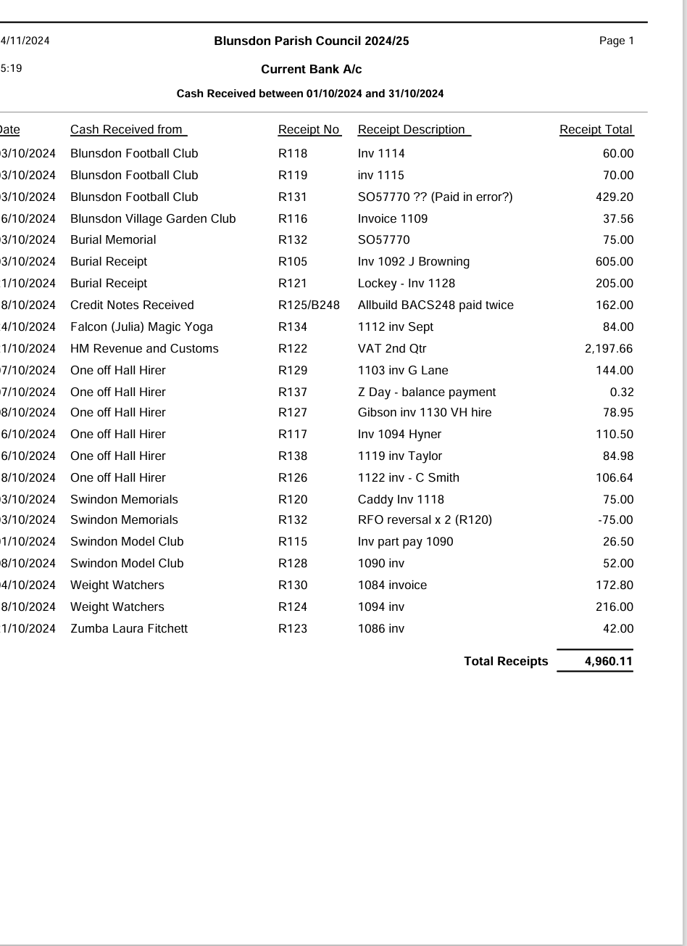
Date: 14/11/2024  Time : 15:12 |  | Blunsdon Parish Council 2024/25  Current Bank A/c  Payments made between 01/10/2024 and 31/10/2024 |  |  |  |  | Page 1
Payment  Date Reference |  |  | Payment Detail | Net Amount | VAT Amount | Total Amount | VAT Code
Allbuild and Landscaping Serv  23/10/2024 BACS282 |  |  | 3050 inv - Hyde rd clearance | 300.00 | 60.00 | 360.00 | S
23/10/2024 BACS283 |  |  | 3045 inv - Grass cuts Sept | 1,200.00 | 240.00 | 1,440.00 | S
23/10/2024 BACS284 |  |  | 3049 inv - remove tree Hyde | 175.00 | 35.00 | 210.00 | S
23/10/2024 BACS285 |  |  | 3036 inv - Waste 39 bins | 422.50 | 84.50 | 507.00 | S
 |  |  |  | 2,097.50 | 419.50 | 2,517.00
Arthur J Gallagher Insuranc  07/10/2024 | e  BACS265 |  | Annual Insurance | 5,787.57 | 0.00 | 5,787.57 | Z
31/10/2024 | BACS288 |  | 538408922 inv Pav insurance | 99.67 | 0.00 | 99.67 | Z
 |  |  |  | 5,887.24 | 0.00 | 5,887.24
BRITISH GAS LITE 15/10/2024 | DD |  | Inv 8889417 26/8 - 26/9/24 | 167.53 | 8.38 | 175.91 | F
Corona Energy  15/10/2024 | DD |  | 2497932 Sept VH Electric | 118.43 | 5.93 | 124.36 | F
Everflow water  29/10/2024 | DD |  | 3721818 inv - Water Pav VH | 110.65 | 0.00 | 110.65 | Z
Hayley Seagroatt  31/10/2024 | BACS286 |  | 41 inv VH clean Oct | 650.00 | 0.00 | 650.00 | Z
Heard & Son Fencing Limited  18/10/2024 BACS275 |  |  | 0175 inv - Flora Close | 770.00 | 154.00 | 924.00 | S
Hills Waste Solutions Ltd  07/10/2024 BACS263 |  |  | Inv P893728 Sep 24 VH | 48.10 | 9.62 | 57.72 | S
HM Revenue and Customs 24/10/2024 DD |  |  | Aug & October 24 Tax | 2,237.74 | 0.00 | 2,237.74 | OTS
Instant Access  23/10/2024 T-23-10-24 |  |  | CIL/24 Current to Instant Acc | 40,263.15 | 0.00 | 40,263.15
Liza's Easy Cleaning Services  24/10/2024 BACS291 |  |  | 81 inv Oct Pav cleans | 68.94 | 0.00 | 68.94 | Z
REF3  04/10/2024 | BACS259 |  | Week 26 | 106.00 | 0.00 | 106.00 | OTS
04/10/2024 | BACS262 |  | MILEAGE on Week 26 | 5.12 | 0.00 | 5.12 | OTS
09/10/2024 | BACS270 |  | Week 27 | 96.64 | 0.00 | 96.64 | Z
18/10/2024 | BACS273 |  | Week 28 | 74.82 | 0.00 | 74.82 | OTS
21/10/2024 | BACS276 |  | Week 29 | 124.70 | 0.00 | 124.70 | OTS
24/10/2024 | BACS297 |  | Wk 31 | 93.53 | 0.00 | 93.53 | OTS
24/10/2024 | BACS297 |  | Wk 31 | -93.53 | 0.00 | -93.53 | OTS
 |  |  |  | 407.28 | 0.00 | 407.28
REF4
31/10/2024 | BACS290 |  | REF 4 - Oct 24 | 1,055.38 | 0.00 | 1,055.38 | OTS
REF2 |  |  |  | 1,055.38 | 0.00 | 1,055.38
Continued on Page 2

Date: 14/11/2024  Time : 15:12 | Blunsdon Parish Council 2024/25  Current Bank A/c  Payments made between 01/10/2024 and 31/10/2024 |  |  |  |  |  | Page 2
Date | Payment  Reference Payment Detail Net Amount |  |  |  | VAT Amount |  | VAT Total Amount Code
31/10/2024 BACS299 |  | REF 2 OCT 24 | 1,219.62 | 0.00 |  | 1,219.62 |  | OTS
31/10/2024 BACS301 |  | REF 2 - HW Oct 24 | 25.00 | 0.00 |  | 25.00 |  | OTS
REF 1 |  |  | 1,244.62 | 0.00 |  | 1,244.62
31/10/2024 BACS298 |  | REF 1 - October 24 | 1,993.28 | 0.00 |  | 1,993.28 |  | OTS
31/10/2024 BACS300 |  | REF 1 - HW Oct 24 | 35.00 | 0.00 |  | 35.00 |  | OTS
Nat Assocn of Local Councils |  |  | 2,028.28 | 0.00 |  | 2,028.28
23/10/2024 BACS280  Panache Sparkle Ltd |  | SD 1621-1 inv - Job advert | 211.00 | 42.20 |  | 253.20 |  | S
03/10/2024 BACS266 |  | Invoice 71152397 Deposit | 695.00 | 0.00 |  | 695.00 |  | Z
09/10/2024 BACS267 |  | Balance of inv 71152397 | 900.00 | 0.00 |  | 900.00 |  | Z
Ryal Media Group Ltd |  |  | 1,595.00 | 0.00 |  | 1,595.00
23/10/2024 BACS279  Saunders Metals LTD |  | Rialtas Business Solutions | 136.80 | 27.36 |  | 164.16 |  | S
31/10/2024 BACS287  Society of Local Council Clerk |  | 016462 inv skip change | 185.00 | 37.00 |  | 222.00 |  | S
23/10/2024 BACS281  Spot On Supplies (Cleaning)Ltd |  | 702787 inv - Job advert AC | 300.00 | 60.00 |  | 360.00 |  | S
16/10/2024 BACS278  Stand Out Window Cleaning Serv |  | 12219417 inv VH | 35.60 | 7.12 |  | 42.72 |  | S
07/10/2024 BACS274 |  | 0165 - window clean VH | 150.00 | 0.00 |  | 150.00 |  | Z
 |  |  | 0.00 | 0.00 |  | 0.00
59,768.24
771.11
60,539.35

