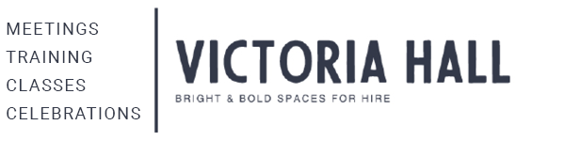
Housekeeping During Your Hire

Please make staff aware of any disabled visitors/wheelchair users in your group.

In the event of a Fire - please leave the building by the nearest fire exit and stand outside the gate at the assembly point at the (Green & White) sign, a staff member will manage the situation until the emergency services arrive.

Please ensure the fire exists are not blocked with any furniture or equipment.

Furniture: Please do not drag furniture as it damages the flooring

Tables: 2 people to lift and NOT drag tables
Please use table coverings if serving food or during arts & crafts activity

Chairs: Please follow the stacking sign when putting away chairs, push loaded stacks slowly, best with two people

Table coverings must be used at all times

The use of glitter, live flames, candles or sand is not permitted on site

Balloon arrangements must be taken off site on departure.

If using the stage with décor props/cake cutting etc. The stage floor needs to be covered

Toilets: Please ensure nappies are placed in the waste bins provided &
that Hand Towel is NOT thrown in the toilets

Refreshments: Electrical food warmers only, no chafing dishes, deep fat fryers/deep fat frying allowed on site

You have accepted VH Terms & Conditions of Hire; which means you leave the hired space as found, returning furniture to is original position/storage area. All rubbish/food debris to be cleaned up & taken to our onsite bin store. We have a Cleaning Caddy with wipes/sprays etc. to help with the clear up.

Wifi: Guest - Victoria Hall Harrow PW - VictoriaHallHarrow
If you have any questions, please do ask a member of staff

