https://horley.lemonbooking.com/
N.B. These instructions are applicable for all 3 RBBC community centres.
https://woodhatch.lemonbooking.com/
https://banstead.lemonbooking.com/

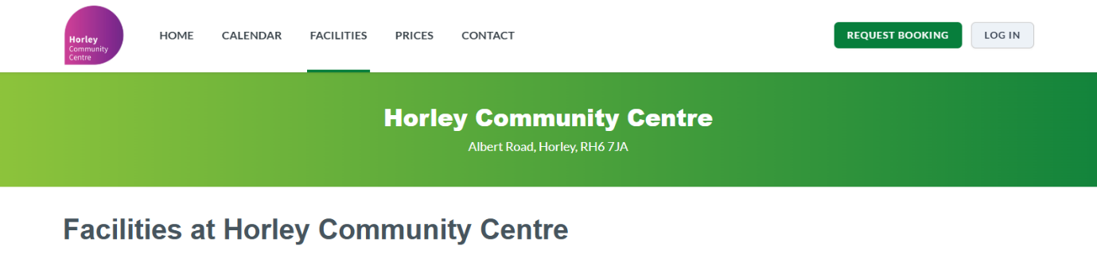
Head to the FACILITIES page on the top banner.
This page will enable you to view all spaces for hire at the centre.

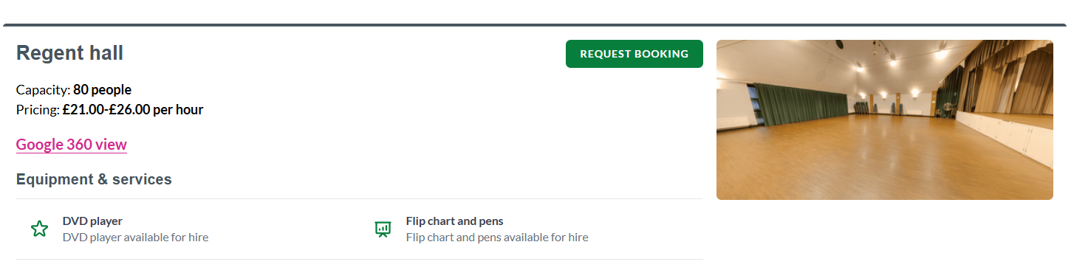
Once you have chosen the facility you would like to enquire about, select REQUEST BOOKING

Complete the customer details and CONTINUE with your booking request
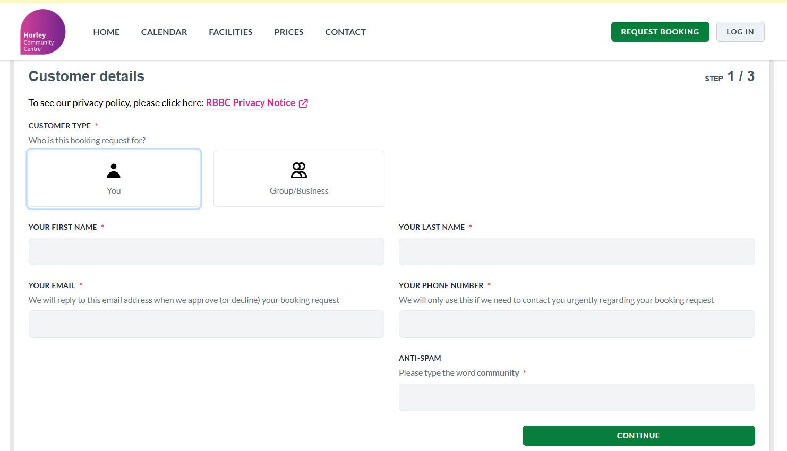

Select your BOOKING CATEGORY from the drop-down list.
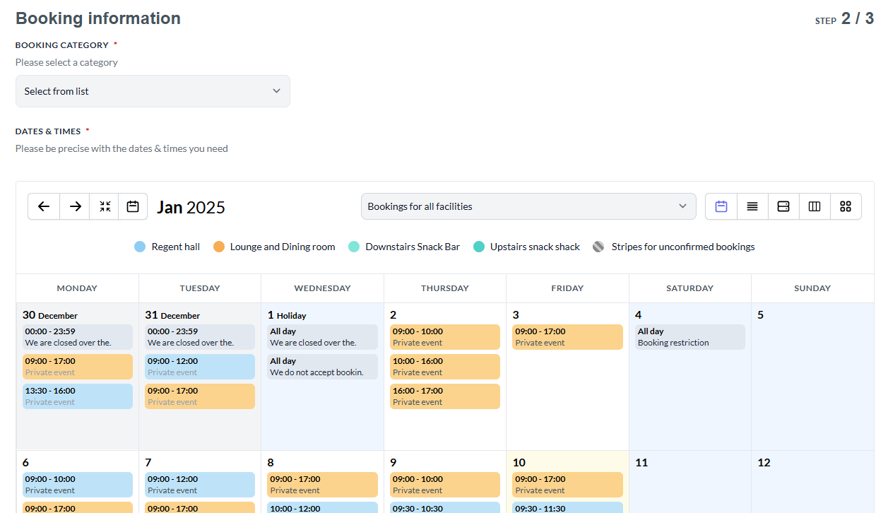

Using the calendar, select the DATE you wish to book.
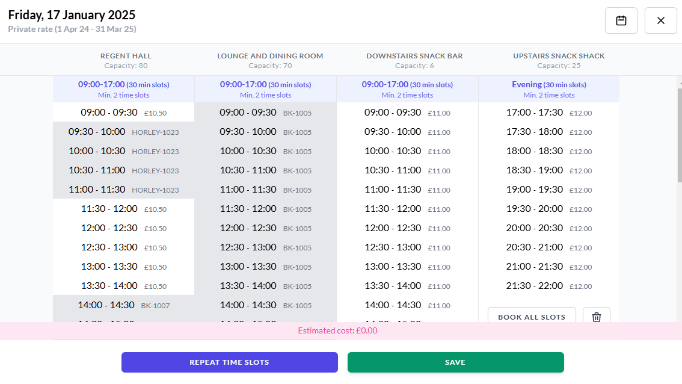

Select the TIME – if the time you require is greyed out, this means it is unavailable.
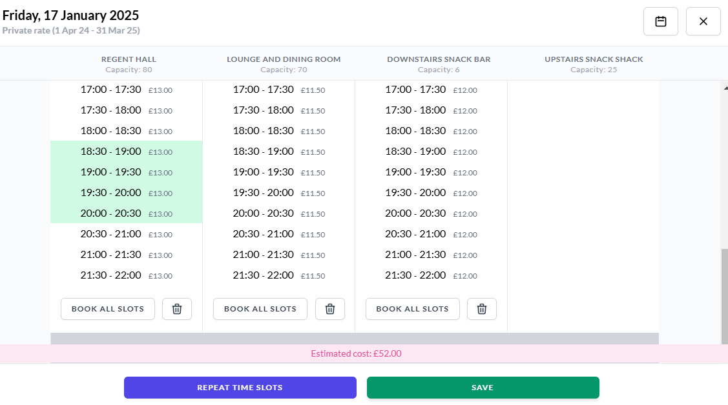
When selected, the time will highlight green. Click SAVE
If you wish to request another time/date, repeat the previous step.
Scroll down the page to complete further information about your booking.
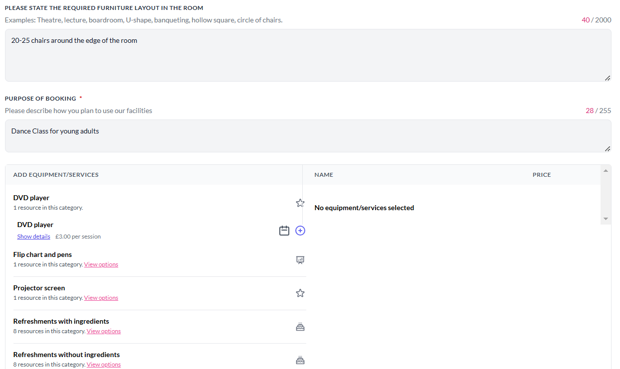
Here you can add your furniture requests/room layout, the purpose of the booking, any additional equipment/refreshments, how many participants and any other information you feel necessary to comment about the booking.
At the bottom of the page, it will ask if you wish to save your booking preferences.
Click CONTINUE
Complete your billing address details.
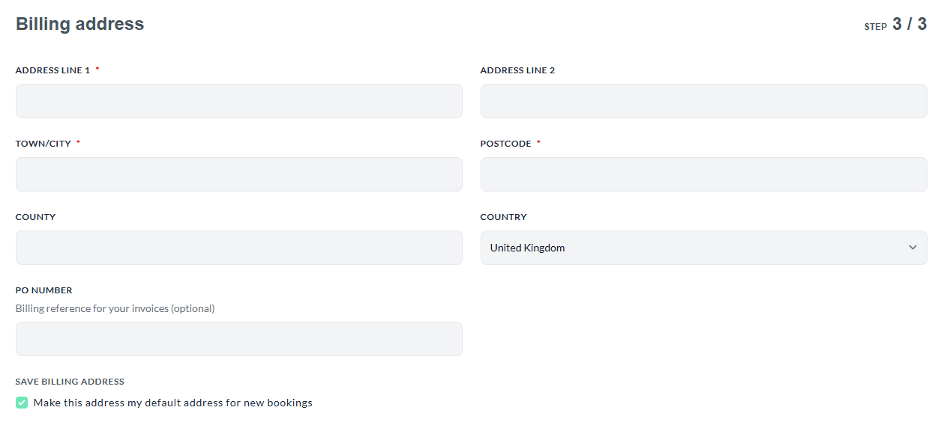
If you feel your booking benefits the community, you can request reduced rates by filling in the final box with these details.
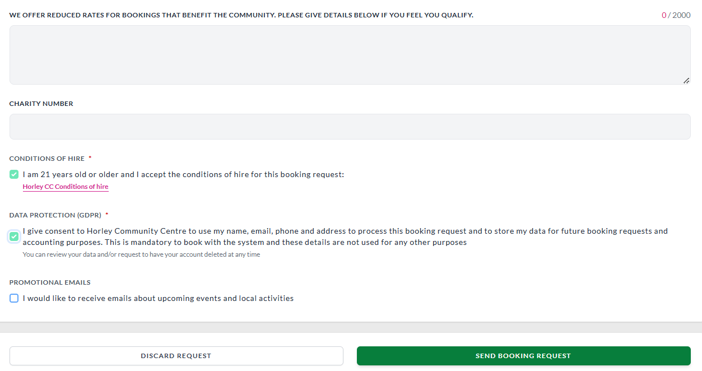
SEND BOOKING REQUEST
You will then see a booking request summary and can view a copy of the pending booking request form. The centre will review your request and accept/decline accordingly.
You will receive two emails, one to register your account with a password already assigned (which you can change when you log onto your account), and one confirming the booking details.

