SPEAKER AND MICROPHONE INSTRUCTIONS
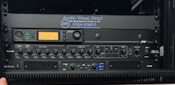
The speaker control cabinet is located in Store Cupboard 1 – THIS WILL BE LOCKED AS YOU DO NOT NEED TO USE IT.

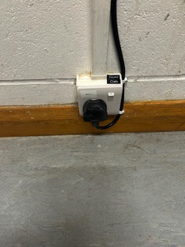
On the wall outside of Store Cupboard 1 turn the power on to activate the speakers. Ensure Bluetooth is turned on on your device and search for ‘Music BT’ enter the pass code ‘0000’ you are now connected.

Ensure that the power supply below the cabinet is turned on.

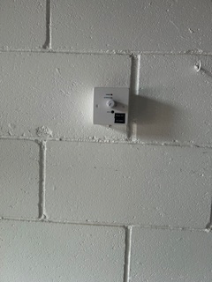
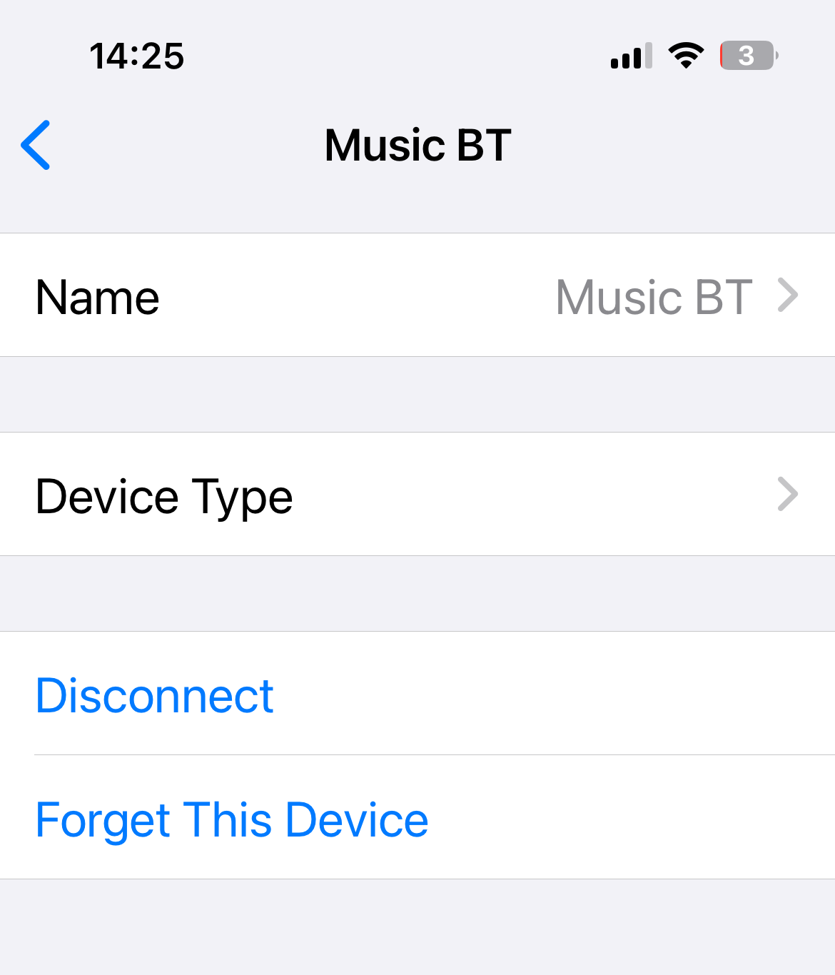
Once you have finished using the speakers please turn off the power on the wall and click Forget this Device on your device – do not just disconnect as you will automatically reconnect if it is turned on again.
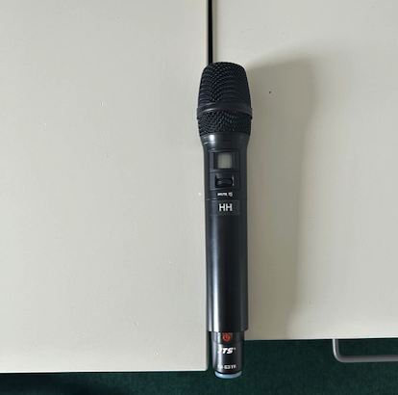
The microphone is stored in the clear plastic box in Store Cupboard 1. To turn it on push the MUTE button up. To turn it off push and hold the red button until OFF is displayed on the screen.

