

Hall User Guide

Welcome to Meldreth Village Hall. We’re really pleased you’ve chosen to hold your event here.
This guide is here to help everything run smoothly and to make your hire as easy and enjoyable as possible. It covers what you need to know before, during, and after your event.
If you’re unsure about anything, please don’t hesitate to get in touch - we’re always happy to help.
Contents
BEFORE YOUR HIRE 3
Floorplan of the hall 3
Health & Safety 3
Booking 3
Setup & clear-down time 3
Payments 3
Deposits 3
Cancellations 3
Capacity 3
Licences 3
Insurance and liability 4
Bouncy Castles 4
DURING YOUR HIRE 5
Access and arrival 5
Parking and use of the carpark 5
Heating 5
Layout and light switches 6
Tables and chairs 7
Kitchen and Serving Equipment 8
Stage 9
Projector and Screen 9
Speakers and microphones 9
Garden Use 9
Candles 9
Decorations 10
Problems including accidental damage or breakages 10
END OF YOUR HIRE 11
End of Hire Responsibilities 11
Rubbish and Recycling 11
Cleaning Equipment 11
Damage 12
Key return 12

BEFORE YOUR HIRE

Floorplan of the hall
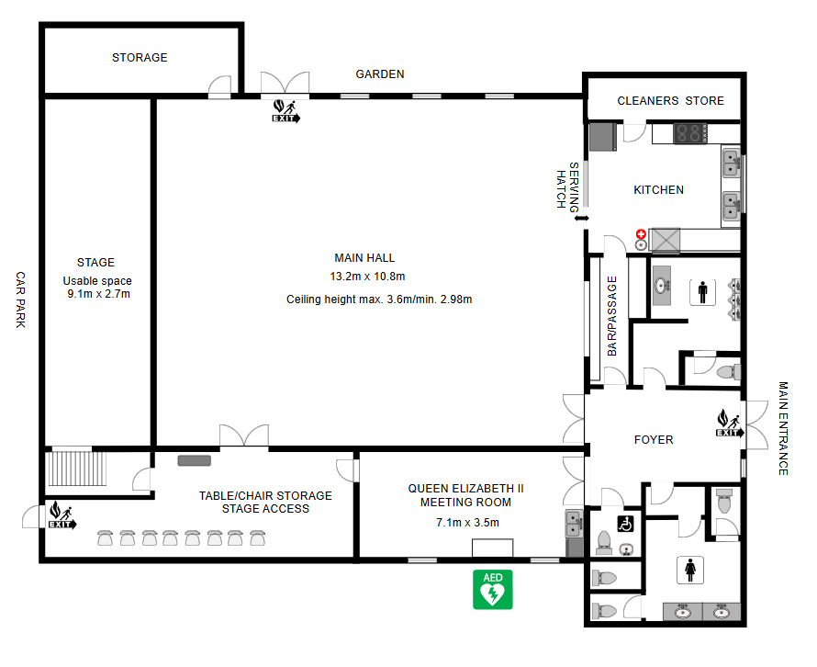

Health & Safety
Before your hire, please take a few minutes to read and familiarise yourself with the Hall’s Fire Safety Policy and emergency instructions. These are available on our website, displayed on noticeboards around the hall, and will also be sent to you ahead of your booking.
For your information, the following safety equipment is available on site:
- A whistle for gaining attention, clearly signposted and kept in the kitchen
- Fire extinguishers located in the kitchen and near fire exits
- A first aid kit and accident book kept in the kitchen — please ensure all accidents are recorded
- An AED (defibrillator) located on the outside wall of the building on the Elin Way side
Postcode: SG8 6LB
what3words: condensed.reworked.bracelet

Booking
Bookings are made via the booking system (LemonBooking) on our website meldrethvillagehall.co.uk.
Bookings are confirmed once payment (and deposit if required) is received.
All bookings are subject to:
- Standard Conditions of Hire
- Payment, Deposit & Cancellation Policy

Setup & clear-down time
Hirers must include sufficient time for setup and clearing down.
We recommend at least:
- 30 minutes before your event
- 30 minutes after your event
Bookings can run back-to-back, so it is important to allow enough time, particularly if you are using external suppliers (e.g. bouncy castles).

Payments
See separate Payment, Deposit & Cancellation Policy

Deposits
See separate Payment, Deposit & Cancellation Policy

Cancellations
See separate Payment, Deposit & Cancellation Policy

Capacity
- 200 seated (160 chairs available)
- 150 for party/dance events
- QEII room: up to 15 people

Licences
Meldreth Village Hall holds the following licences:
- Premises Licence from South Cambridgeshire District Council which authorises the following regulated entertainment and licensable activities:
  - Performance of plays (indoors)
  - Performance of live music (indoors)
  - Playing of recorded music (indoors)
  - Performance of dance (indoors)
  - Entertainments of a similar description
- Music Licence from PRS and PPL
The Village Hall is NOT licenced for the following:
Alcohol
The Village Hall is NOT licenced for the sale of alcohol. Hirers may apply for a Temporary Event Notice (TEN) from South Cambridgeshire District Council if required.
As part of the hire agreement, hirers must inform us if they intend to apply for a licence for the sale of alcohol, as the number of TENs is limited per year.

TV

Please note that the village hall does not hold a TV Licence.

This means that hirers must not use any device in the hall (including televisions, laptops, tablets, phones, or projectors) to watch: Live television broadcasts (via any channel or streaming service) BBC iPlayer (live or catch-up content).

This applies regardless of whether the device is mains-powered, battery-operated, or using mobile data or Wi-Fi.

Hirers remain responsible for ensuring that any use of audio-visual content in the hall complies with TV Licensing regulations.

On-demand content that is legally downloaded and played offline (not streamed live) may be permitted.

Insurance and liability

Bouncy Castles
See separate Bouncy Castle Policy

Entertainment

DURING YOUR HIRE

Access and arrival
Access details will be sent to you before your hire.
The Main Hall and QEII Meeting Room can be hired separately, so there may be another group using the building at the same time as you. Where possible, we will let hirers know about other bookings in advance.
We ask that you are considerate of others, particularly with noise. Before leaving, please check that everyone in your group has left the building. The hirer whose booking ends last is responsible for ensuring the building is left secure and properly locked.

Parking and use of the carpark
The car park is located at the rear of the hall and is accessed via the High Street. There is space for approximately 30 cars.
You may stop briefly outside the rear door for loading and unloading. However, this is a fire exit and must be kept clear at all times.
The car park is shared and spaces cannot be guaranteed. Additional parking is available on Elin Way and along the High Street.
Parking in the car park is at users’ own risk, and overnight parking is not permitted.
When leaving the hall, especially later in the evening, please be considerate of our neighbours and keep noise to a minimum.

Heating
Heating is preset for each booking. You can increase or decrease the temperature via the thermostat in the bar passage.
Please do not adjust the wall heaters.
You may switch on the wall heaters in the QEII meeting room but please remember to switch them off at the end of your hire.
We do not have air conditioning.

Layout and light switches
Please also refer to the floorplan
Foyer
As you enter the building through the front door, the light switch for the foyer is on the wall to the left. Above the door are switches which indicate which lights are on in the building – please check as you leave.
On the noticeboards you will find copies of all relevant policies, license and insurance information along with the details for the WiFi and any other information you may need.
Toilets
Off the foyer there are separate female toilets, male toilets, and an accessible toilet with nappy changing facilities. Please ensure used nappies are taken away and not left on-site. Lights for all toilets are manual switches/pull cord.
Main Hall
Entry to the Main Hall is via the double doors from the foyer.
The light switches are in the bar passage at the kitchen end (if entering the hall at night ensure the light in the foyer is on).
Bar passage
There are separate switches for the wall and ceiling lights plus a switch for the bar passage.
Here you will also find cleaning equipment including a floor sweeper and vacuum cleaner here.
The bar passage leads to the kitchen.
Kitchen
The kitchen light switch is on the right-hand side as you enter.
In the kitchen you will find:
- A handwashing/emergency eye wash station
- First aid kit and accident book

Tables and chairs
The following tables and chairs are available for use:
Quantity | Type | Storage Location
17 | Gopak tables (6ft x 2ft 3”) | Stacked against wall in the Storage Room
1 | Gopak tables (6ft x 2ft 3”) | Stored in kitchen
160 | Stackable cushioned chairs | Storage Room
4 | Plastic chairs | Kitchen
14 | Small tables (suitable for children) | Storage Room
30 | Children’s chairs (red and blue) | Storage Room
4 | Foyer/meeting chairs | Foyer or QEII Meeting Room
1 | Round display table | Available on request

The storage area is located on the left-hand side of the Main Hall and also connects to the QEII Meeting Room. All tables and chairs available for your hire are stored here.
Please use the chair trolleys provided when moving stacks of chairs - do not drag chairs across the floor, as this can cause damage. A tool is available on the wall to assist with folding table legs.
Children must be supervised in this room and should not use the trolleys.
Please ensure all tables are wiped clean at the end of your hire and returned correctly back to the storage room - refer to the storage instructions on the wall.
Please return all furniture at the end of your hire.
Access & safety
- A door from this area leads to steps up to the stage
- A fire exit from this area leads directly to the car park
Safety note
Children must not access the stage unless supervised by an adult
Table tennis tables
Table tennis tables stored here belong to the Village Hall Table Tennis Club and are not available for general use. Please do not use these during your hire.

Kitchen and Serving Equipment
Kitchen applicances:
- Single electric oven (with baking trays)
- 4-ring electric hob
- Microwave
- Air fryer
- Hot water boiler (please switch on 10 minutes before use and remember to switch off at the end of your hire)
- 50/50 fridge freezer – (please do not switch off. Please remove food and drink at the end of your hire)
Glassware, cutlery and crockery
The kitchen cupboards and drawers contain a range of items available for use during your hire, including:
- A good selection of mugs, plates, bowls, cutlery, and everyday glassware
- Approximately 70 teacups and saucers
- Approximately 50 wine glasses
- 5 glass jugs
- A selection of plastic children’s plates, bowls, cups, and spoons
A full additional cutlery set for approximately 50 people is also available on request.
Please wash, dry and return items after use.
Kitchen cupboards
Some cupboards are used by regular groups and will be clearly labelled.
Please respect and do not use any items that do not belong to the hall.
Serving hatch
The serving hatch can be pulled down and locked - please take care when operating it.
There is also a lift-up counter providing access between the kitchen and Main Hall.
Please ensure it is securely fastened using the catch when not in use to prevent injury.
Safety note
For safety reasons, we recommend that children are supervised at all times and kept out of the kitchen when cooking or preparing hot food and drinks.
Children must not operate the serving hatch or lift-up counter.

Stage
Hirers are welcome to use the stage, but this is at your own risk. It can be used for DJs, live music, presentations, or performances.
Access to the stage is via stairs in the table and chair storage room. Wooden steps are also available and can be positioned to provide access from the Main Hall floor.
If you are planning a performance, please let us know in advance so we can discuss any AV requirements.
Stage curtains must only be operated using the pulley ropes. Please do not pull the fabric, as this may damage the mechanism.
Safety note
Children must not use the stage without adult supervision.

Projector and Screen
There is a remote-control operated electronic projector screen above the front centre of the stage. There is also a projector mounted to the ceiling. HDMI sockets for the projector are located on the wall to the left of the stage. The projector and screen must be requested at the time of booking – additional charges apply. Instructions for use can be found in Appendix X, Using the projector and screen

Speakers and microphones
The hall has two portable speakers with Bluetooth connection and optional disco lights. There are also two handheld microphones available. Please request at time of booking. Additional charges apply.

Garden Use
Hirers are welcome to use the community garden responsibly. The garden is well fenced but not child-proof, so children must be supervised at all times.
Smoking is not permitted anywhere on site, including the garden.
BBQs, Hog Roasts, or Firepits are not permitted due to fire risk and the timber-clad building.
Vehicles must not be driven into the garden

Candles
Candles for decoration are not permitted. Naked flames and pyrotechnics are strictly prohibited.
Birthday cake candles are allowed within reason, provided they are used under close adult supervision.
Sparkler candles are not permitted.
If you plan to use birthday candles, please bring your own means of lighting them and ensure you take away both the used candles and lighting equipment with you at the end of your hire.
Safety note
Children must never be allowed to light birthday candles or be left unsupervised near fire lighting equipment or lit candles.

Decorations
Freestanding decorations such as balloons, arches, and table décor are welcome.
Do not use BlueTac or sticky tape to attach decorations to walls, ceilings, or painted surfaces.
Electrical Equipment
Hirers may only bring their own electrical equipment into the hall if it has a valid Portable Appliance Testing (PAT) certificate confirming it is safe to use.
All electrical equipment provided by the hall is regularly tested and holds up-to-date PAT certification.

Problems including accidental damage or breakages
If you notice any damage or broken equipment when you arrive at the start of your hire, please take a photograph and email it to meldrethvillagehall@gmail.com (or use the contact form on our website), including a brief description of the issue.
If you discover a more urgent problem - for example the hall has not been left in a suitable condition, or there is significant damage or a spill requiring immediate attention - please contact us using the emergency numbers displayed on the front door.

END OF YOUR HIRE

End of Hire Responsibilities
We operate a ‘please leave as you find it’ policy. Hirers are responsible for leaving the hall clean, tidy, and ready for the next user.
This includes:
- Removing all rubbish (including fridge items)
- Ensuring no rubbish is left on-site or on the access road
- Cleaning spills during and after use
- Sweeping floors / hoovering where needed
- Cleaning kitchen surfaces and washing up all items used
- Returning tables and chairs to storage
- Using chair trolleys (do not drag chairs)
- Leaving toilets tidy (no cleaning required but please leave tidy)
- Taking nappies home

Please refer to the End of Hire Checklist

Rubbish and Recycling
See also – End of Hire Responsibilities
There are two plastic bins in the Main Hall for use during your hire. Please line bins with the black sacks provided. Additional bin bags can be found in the kitchen.
At the end of your hire, all rubbish must be bagged and placed in the blue wheelie bin on the access road.
If the bin is full, please take your rubbish home with you. No waste should be left outside.
If rubbish is left behind, additional charges may apply or part of your deposit may be withheld to cover removal.
We do not currently offer on-site recycling facilities, so we ask that all recycling is taken home for disposal.

Cleaning Equipment
See also – End of Hire Responsibilities
A Henry Hoover is kept in the bar passage along with a floor sweeper and brush and dustpan.
General cleaning supplies such as surface disinfectant, wipes, washing up liquid, sponges, blue roll – are available in the kitchen including the cupboards under the sink.
Please help us take care of our wooden floor by mopping up spills as soon as possible. If there is a large spill or mess please contact one of the emergency numbers on the front door.

Damage
All breakages, damage, or loss must be reported immediately after the hire period to the Booking Administrator (see also – Problems including accidental damage or breakages)
Hirers are responsible for leaving the Hall in a clean, tidy, and secure condition in accordance with the Standard Conditions of Hire and Payments, Deposits and Cancellations Policy.
The Hirer may be charged for reasonable costs arising from:
- additional cleaning
- waste removal beyond normal use
- repair or replacement of damaged property
- use of the Hall beyond the agreed hire period
- loss of keys requiring replacement or lock changes
- any breach of hire conditions that results in additional cost

All charges will be based on actual or reasonably estimated costs incurred by the Hall.

Key return

See also – End of Hire Responsibilities
The key must be returned according to the instructions emailed to you when your booking was confirmed, and no later than 15 minutes after locking up the hall.

Failure to return the key may result in the hirer being charged the reasonable cost of replacement.

The key remains the responsibility of the person named on the booking form and must not be passed on to anyone else, including users attending a subsequent booking.

