

MUGA Booking Instructions

There are three ways to book:
- Purchase a Household Annual Pass for £30 and get discounted access of £3 a session (up to 4 players) and £15 a session (5 or more players).
- One off pay to play via our Walk-in rates of £10 - adults, £5 - under 16s.
- For longer term more routine use by groups (form your own) - contact us.


Annual Pass
- Prices are provided above.
- Register on the booking platform via www.gordonvillage.co.uk.
- Once registered, go to your own dashboard.
- Click membership.
- Apply for membership and provide names and email addresses for all relevant persons in your household.
- Pay.
Once payment is taken, discounted rates for bookings are available using the term ‘Annual Pass’.
All relevant names and email addresses should be provided for those people in your household to access the same discounted rate.
Please follow the process below to then make a MUGA booking where you can access the relevant rates.

Walk-in Bookings

Prices (for hire of the MUGA, not per person)

1 hour - £10 adults (4 players)
1 hour - £5 under 16 (4 players)
1 hour - £30 (5 or more players i.e. 5 aside football)

Walk-in Booking and Access
Routine /occasional bookings can be made online through the booking system available via the village website: www.gordonvillage.co.uk.
You will need to make an online payment at the time of booking. In response, lock codes will be provided. This process should only take a few minutes.
The website provides an availability calendar showing existing reservations and available time slots.
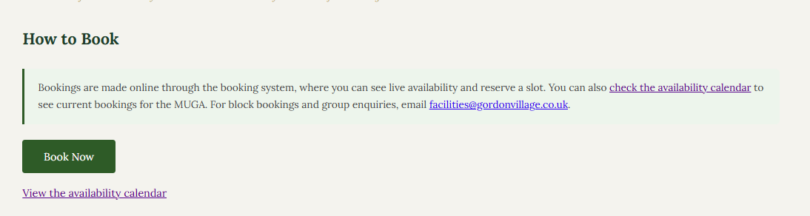
To make a booking, press ‘Book Now’ and choose your preferred day and slot and follow the online booking process.
Note: New users will have to register with the application.
This will take you to the underlying booking application page 1. Select ‘Make Booking’ to progress to choosing a slot. There are seven steps in total, but quick to click through once you are familiar.
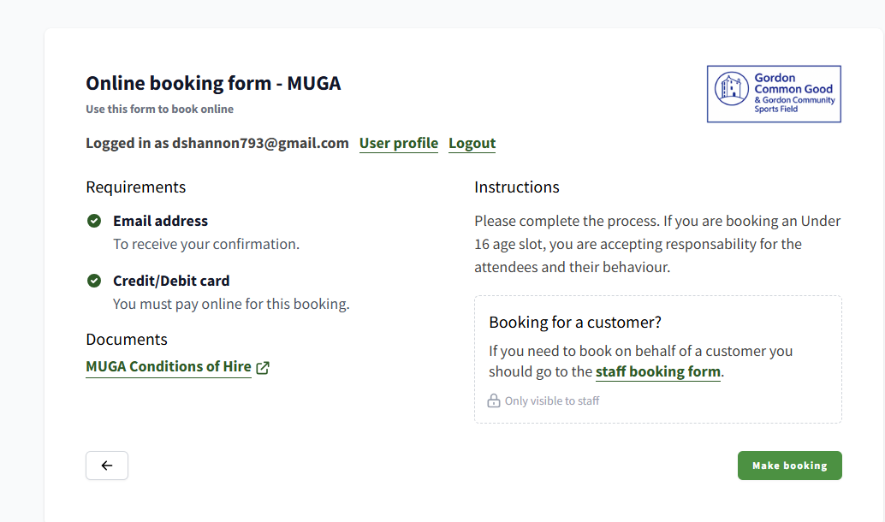
This is an example of the booking form

- Choose the booking group that best applies (if you have 4 or less players or more than 4)

- Choose your preferred slot. Step 3 is if you choose multiple slots.

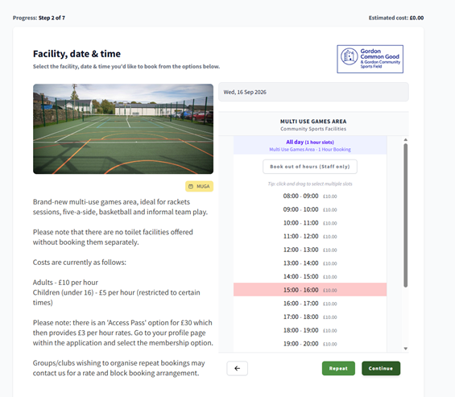
The date can be changed by clicking it.

Select your preferred slot.

- provide supplementary information e.g. what sport are you playing – which helps us.

- Accept T&Cs and privacy policy.

- Make payment.

- Receive booking confirmation with pin code information and invoice.

Help and Assistance

Please contact us at facilities@gordonvillage.co.uk or gordoncommunitysportsfield@gmail.com

