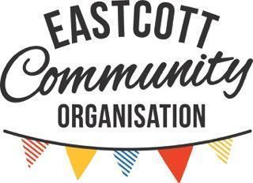

Hiring Agreement (Terms and Conditions)

Eastcott Community Organisation
The use of our centre (Eastcott Community Organisation) and its facilities is subject to the terms and conditions in this hiring agreement as set by our management committee.

About your hire
This Hiring Agreement gives you permission to use the premises for the agreed hire period and means you have no tenancy or other right of occupation.
Make sure your hire includes enough time for you to set up/clear away any equipment needed and to make sure the centre is left in a clean and tidy state at the end of your hire.
Your hire will not be confirmed until you have paid your invoice. You will be charged at the rate agreed with the Community Centre Administrator.
- Use of the centre
You shall not use the premises for any purpose other than that described in this Hiring Agreement.
You must not:
- sub-let
- use the centre or allow the centre to be used for any unlawful purpose or in any unlawful way
- do anything or bring into the centre anything which may endanger or render invalid any insurance policies
We may refuse an application to use our facilities if it presents a risk of public disorder, a risk to national security or a risk of alienating our community. In any doubt, the Community Centre Administrator will not confirm your hire without our agreement.
We reserve the right to request additional information and to make enquiries of external bodies as to the standing of any organisation before we agree to the hire.
If your booking:
- is subject to a complaint by our community or our team
- has breached our terms and conditions/policies,
- has breached any statutory/legal requirements
we may consider whether it is appropriate for you to receive your deposit back and to hire the centre again. If this applies to you, the centre's management committee will consider the situation and will write to you. If you are unhappy with the decision, you can follow the centre's Complaints Procedure.
- Responsibility
You are, during the period of the hiring, responsible for:
- supervision of the centre (buildings and contents)
- health and safety
- behaviour of everybody using the centre. Please note this includes car parking arrangements
You are responsible for making good or paying for all damage (including accidental damage) to the centre or to the fixtures, fittings or contents and for loss of contents.
As the hirer, it is your responsibility to remain onsite for the duration of your booking. At the end of your booking, you must remain onsite until a member of centre staff has returned and inspected the centre.
You agree to only use the hall that you have booked for the duration of your event. If there is evidence of you using other halls on site, you will be charged at the business rate of that hall for the duration of your booking.
- Rubbish
Do not leave rubbish in or around the centre.
We provide cleaning supplies for use at your event. If you have any rubbish, you can leave a maximum of 2 black bin bags in or next to the red bin at the carpark entrance before you leave. Any extra bags will be charged at £10 each.
Recycling bins are available for your use in each hall. Feel free to leave clean plastic, card, paper, or aluminium cans in them. Up to 12 clean, glass bottles can be left in the kitchen. Do not use the recycling bins for general waste or you will be charged £10 per bag.
There are no facilities to dispose of helium canisters, nappies or any other rubbish which would require either a specialist licence or a visit to a waste disposal site. Please check if you are unsure. If these items are left you will be asked to return and collect them. If you do not, there will be a £50 charge to arrange specialist disposal.
- Decoration
You can decorate the centre but everything must be removed by the end of the hire:
- all decorations must be temporary
- use white-tack only to attach things to the wall; do not use drawing pins or Sellotape on the walls or other surfaces
- do not fix decorations near light fittings or heaters
- do not use confetti or glitter unless it is all removed from the centre
- balloons (inflated and deflated) must be removed from the centre
- fabric bunting is installed in the large hall and you must not remove it. If you want it removed you must give at least 2 weeks’ notice and pay a charge of £25.00. This fee may be waived in exceptional circumstances
- no decorations of a combustible nature (such as polystyrene, cotton, etc.) shall be used or put up without our consent
- you are not permitted to hang decorations which require working at height. We will not lend you ladders and ask that you do not bring your own
We will dispose of any unauthorised decorations left on the premises. We will ask you to make good any damage caused by installation and removal of any unauthorised decoration.

- Entertainment
If you wish to arrange entertainment (e.g play equipment, disco) you must ask for permission from the Community Centre Administrator before the event. These things must be considered:
- does the activity fit in the hall? Main Hall is 8.9m wide by 14.7 to 16.1m long. Small (Activity) Hall is 5.3m wide by 11.7m long. Small Hall alcove is 1.8 x 5.3m.
- performances must not be a danger to the public
- performances must not be of a sexually explicit nature
- performances must not cause a noise disturbance to our neighbours (the Centre is situated in a residential area)
Please note: you must read the entertainers full instructions and guidelines and provide a copy of the entertainers Insurance policy
- Advertising
If you publicly advertise your event please make sure you do so legally and have any relevant permissions.

Please note that any and all advertising and publicity material for your event must clearly and prominently display the name of your organisation or group, and make it clear that your organisation or group is the sole organiser.

Under no circumstances must such material convey the impression that Eastcott Community Organisation is in any way involved in organising the event. It must not convey the impression that Eastcott Community Organisation is doing anything other than providing the venue and any services associated with the venue.

This condition applies irrespective of whether the publicity material appears online, in print, in any form of broadcast media or is transmitted by word of mouth.

Failure to make such material clear on this point will be regarded as a breach of the terms and conditions of hire.

- Public bookings
If you are a regular block booking (booking the centre for regular weekly or monthly sessions) then in addition to this hiring agreement you must provide the following for your activity:
- copy of your Insurance policy
- completed risk assessment
- signed copy of your Equal Opportunities policy (or evidence that you are exempt - in line with the 2010 Equalities Act)
- signed copy of your Safeguarding policy
- evidence that you have the relevant qualifications
Payment must be made monthly and paid in advance.

About your payment
You will be invoiced for the hire. Your hire will not be confirmed until you have paid the invoice. If you have not paid 14 days before the hire it will be cancelled. Payments will be accepted by BACS, Cash or Cheque.
If your hire goes on longer than your hire period you will be charged for each full half hour period.
A deposit of £75 is taken for all bookings and will be invoiced to you alongside your hire fee total. This deposit will be returned to you if you have met the terms and conditions in this document. Deposits are returned by cheque, and are processed no later than 14 days after your booking has taken place. It is your responsibility to ensure you provide an up to date postal address for your deposit cheque to be returned to.
In special circumstances, a deposit payment may be waived, however, this will be at the discretion of the centre’s committee.
- If you book late
Bookings made within 14 days of your booking will incur a £10 late booking fee.
- If you make changes
We know that sometimes you might need to change the time of a booking at short notice. We can try to do this for you but depending how soon you let us know there may be a charge. This covers our administrative costs. If we can make the change, the charges are:
- changes made 14 days or more before your booking: No charge
- changes made with less than 14 days’ notice: £5 per change (change to start & end time = £10)
- If you cancel
  - Cancellations made 14 days or more before your booking: a full refund will be given
  - Cancellations made with less than 14 days and more than 72 hours before your booking: 50% of the your fee will be returned
  - Cancellations made with less than 72 hours before your booking: the amount of hire fee refunded will be at the committee’s discretion
- If we cancel
If we have to cancel your booking, we will contact you, giving you as much notice as possible. Reasons we may need to do this are:
- if the centre is needed for use as a Polling Station for a Parliamentary or Local Government election or by-election
- if we find out that your booking will break any legal or statutory requirements
- if we find out that your booking is unsuitable or breaks this hiring agreement
- if it's not safe for you to use the facilities (weather, no water, building damaged)
- if we have been asked to use the facilities as emergency shelter for the victims of flooding, snowstorm, fire, explosion or those at risk of these or similar disasters
In any of these situations we will refund any money already paid linked to the cancelled booking. We are not liable for any costs you incur as a result of us cancelling your booking.
In any situation leading to cancellation which is outside your control, we will refund any money already paid linked to the cancelled booking. This may not apply if you have not taken reasonable steps to research legal requirements and apply for licences etc in good time, in which case the usual refund policy in 2c will apply.

3 About your guests
Please ensure that your guests behave in a sensible manner throughout your hire.
You must comply with the Equality Act 2010, i.e. You must ensure that the centre is open to all. We welcome everyone regardless of sex, sexual orientation, nationality, age, disability, race, or of political, religious or other opinions. By signing the hire agreement, you agree to comply with our Equal Opportunities policy. A copy is available on the centres website https://www.book-online.co.uk/eastcott and in the centres foyer.
- About Supervising people
You or the person in charge of the activity must:
- be 18 years of age or over
- be on the premises for the entire period of hire
- ensure there are a minimum of two responsible adults to carry out general supervision per hall
Please note: If the majority of those attending are less than 16 years of age and/or when many people with disabilities are expected to attend, the numbers of responsible adults must be increased.
At no time should children be left unsupervised or be permitted to wander around the centre or in the car park.
You or the person in charge of the activity must understand the evacuation procedure of the centre and familiarise yourself with the fire-fighting equipment provided.
- Alcohol / illegal drugs
It is your responsibility to ensure that:
- alcohol is not served to anyone already drunk or under the age of 18
- your guests do not drink to excess
- illegal drugs are not taken in or around the premises
- anyone suspected of being drunk, under the influence of drugs or behaving in a violent or disorderly way leaves the centre.

If you are serving alcohol at your Private Party, you must ensure no alcohol is consumed after 6pm, regardless of the finish time of your party.

If your booking is on behalf of an Organisation, please contact the Community Centre Administrator to discuss your requirements. No alcohol can be sold without a Temporary Event Notice for the sale of alcoholic liquor.
- Loss of your property
We accept no responsibility for any property or stored equipment brought onto or left at the centre and all liability for loss or damage needs to be covered by you or your insurance.
If you leave any of your property at the hall, please email bookings@eastcottcommunity.org and we'll put it aside for you. Any unclaimed lost property will be kept for a month before it is given to charity.
- Noise
You are responsible for ensuring that the noise level of your activity does not interfere with other activities within the building or cause inconvenience for the local residents. Please keep the front doors closed.

4 About your safety
You must not endanger the users of the building or invalidate our buildings and contents insurance. In particular:
- you must keep yourself and your guests safe and secure
- you must read and digest the safety notices displayed in the halls
- if moving furniture please use the provided trolleys in order to avoid injury
- no smoking is allowed anywhere on site including the garden between the halls
- highly flammable substances must not be brought into or used in any part of the premises
- do not use smoke machines or anything else which could trigger the smoke detectors
- make sure you know where the escape routes are and keep them clear
- the emergency lighting supply must be turned on during the whole time the premises are occupied and must illuminate all exit signs and routes
- fire extinguishers must not be moved and only used for their intended purpose
- you must call the Fire Brigade for any outbreak of fire, however slight, and full details of the occurrence shall be given to the Bookings Administrator
- in the event of a false alarm please call the emergency phone number which can be found on all the notice boards at the centre. A volunteer will reset the alarm on site
- no unauthorised heating appliances shall be used on the premises
- You are required to bring your own First Aid Box as the centre does not make one available for general use.
- any mains electrical equipment you bring into the centre must have been PAT tested for safety. We will not accept responsibility for any claims and costs arising from the use of your equipment if it has not been tested. A residual circuit breaker (RCD) is built into the electrical circuit within the centre. Additional RCD plugs are available, please ask the bookings administrator if you need one. (PAT testing is otherwise known as Portable Appliance Testing and is a requirement for compliance with the Electricity at Work Regulations 1989)
- hooks have been fitted to enable the blinds to comply with safety legislation. Please ensure that you use them
- ensure all fire exits are clear
- ensure there are no obvious fire hazards on the premises.
- About any Accidents or dangerous occurrences that happen
You must report all accidents to the Community Centre Administrator as soon as possible and complete the relevant section in our accident book. The accident book can be found in the foyer, it is our responsibility to ensure that it is available.
Certain types of accident or injury must also be reported to the Health and Safety Executive. Community Centre Administrator/Health & safety trustee can give assistance in making this report. This is in accordance with the Reporting of Injuries, Diseases and Dangerous Occurrences Regulations 1995 (RIDDOR)2.

Our property
You are responsible for:
- the cost of repair of any damage (including accidental and malicious damage) done to any part of the centre, associated land or its contents
- all claims, losses, damages and costs made against or incurred by us, our employees, volunteers or attendees in respect of:
    - damage
    - loss of property
    - injury to persons
arising as a result of your use of the centre (including the storage of equipment).
- all claims, losses, damages and costs made against or incurred by us, our employees, volunteers, or attendees as a result of any nuisance (doing something that harms other people's rights) caused to a third party (someone other than us or you) as a result of your use of the centre.
You must ensure you have the right insurance to cover these.
We have contents insurance to insure the liabilities described in sub-clause (i) above. You will have to pay any excess and difference between the cost of the repair and insurance monies received.
We are insured against any claims arising out of our own negligence.
- Hours of opening
We are open :
8am - 9.30pm (Sunday-Thurs)
8am - 10.30pm Fridays and Saturdays
Latest time to hire centre
Weekdays (Sunday - Thurs)
Latest 9.30pm for groups and organisations
Latest 8pm for private parties
Fridays and Saturdays
Latest 10.30pm for groups: organisations
Latest 8pm for private parties July to end September
Latest 9pm for private parties October to end June
Later finish times will be at the discretion of the committee.
The end times reflect our commitment to avoiding disturbance for local residents when you/your guests leave events. For the same reason, we may also refuse late or long bookings on consecutive weekend days and will consider this on a case-by-case basis when you submit your booking request.
- Maximum capacity
The main hall has a maximum capacity of 100 people and the small hall has a maximum capacity of 40 people seated (these figures include helpers and performers) and these numbers cannot be exceeded.
- Supply of food and drink
We are not registered as a food premises, therefore food cannot be prepared on site but there is basic equipment for heating food and keeping it refrigerated.
It is your responsibility to ensure that you comply with all legislation to ensure that food and drink is safe and fit for consumption. In particular dairy products, vegetables and meat on the premises must be refrigerated and stored in compliance with the Food Safety (Temperature Control) Regulations 1995. The premises are provided with a refrigerator thermometer.
If you intend to serve food to the general public, with or without payment, you must ensure that food safety is practised. If you intend to do this regularly it is essential that you register with the Environmental Health Department of Swindon Borough Council. Environmental Health can be contacted at: https://www.swindon.gov.uk/info/20137/food_health_and_safety/979/food_business_registration

- Storage
If you need to store items at the centre for a particular function or event, please speak to the Community Centre Administrator to see if this is possible. Items to be stored within the centre must have approval from the centre management committee. We will not store flammable substances.
All equipment and other property must be removed or stored away at the end of each hire.
If property is not removed, or stored away, or removed from storage at the end of hiring agreement at the centre, we will dispose of it and we may charge you any costs incurred. We reserve the right to sell such items if they are of value and to regard any profits made as a donation to Eastcott Community Organisation.
- Car parking
There is a small car park with around 20 spaces and can be used on a first come first served basis. Cars must not cause obstruction at the entrance to, or exits from, the centre. You and your guests should avoid disturbing the residents on arrival and departure. Please note surrounding streets have residents parking and you may be fined if you park there.
- Housekeeping
You must return furniture and equipment to its original position and ensure all doors and windows are locked. All hirers must leave the premises and surroundings in a clean and tidy condition.
Example images of the layout of both Savernake Hall and Raggy Powell Hall are included below, and hall/s must be left as they were at the beginning of your booking:
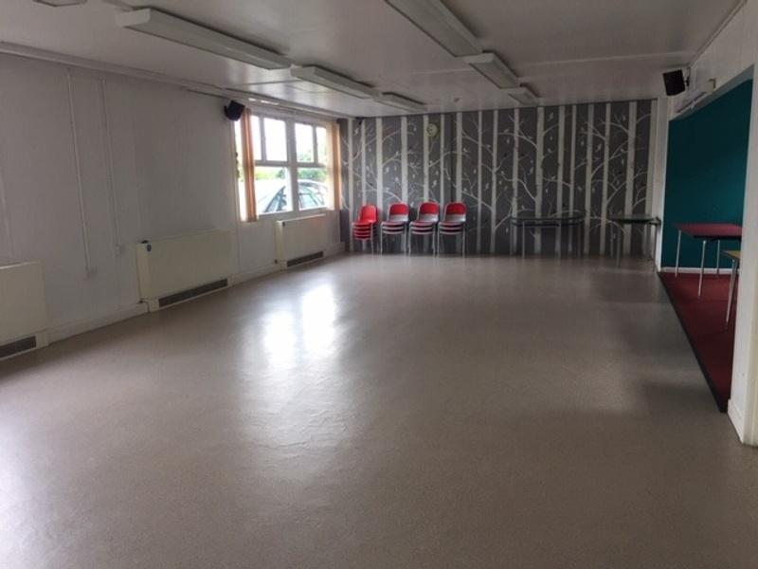
Savernake Hall
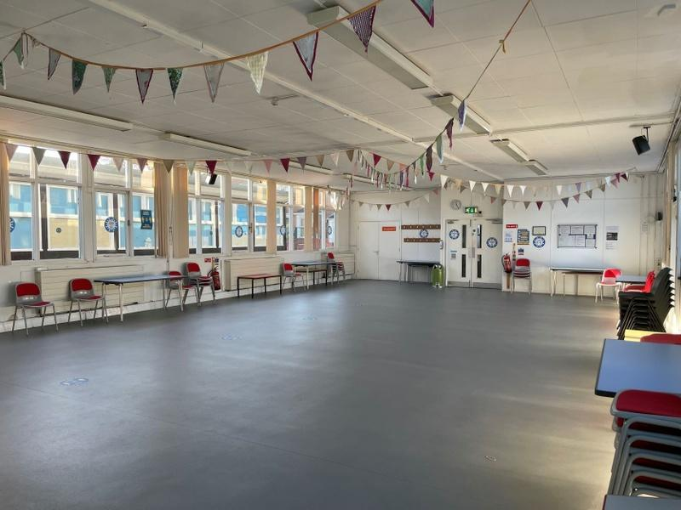
Raggy Powell Hall

Do not bring any cleaning products to the centre, as these may react with products we already use. Please ensure the cleaning products provided are kept out of the reach of children, and use them safely and in accordance with the manufacturer’s instructions.
If cleaning, moving furniture or removal of decorations etc is required in excess of our usual arrangements, we may charge £25 an hour for the additional work.
If the booking is a long booking – either of the options listed below, we'll add an extra hour cleaning to the hire charge. This cleaning charge is £25 for the hour.
- over 4 hours long and where both halls have been hired
- over 6 hours where one hall is hired
- Footwear
All footwear worn should have non-marking soles. If the floor is discoloured or otherwise damaged by footwear we may need to make additional charges for specialist cleaning or repair.
- Animals
You must not allow animals other than trained assistance dogs into the centre unless permission has been sought and given.
You must not allow animals to go into the kitchen.
- Hearing Loop/sound system
We have a standard induction hearing loop in the main hall, and an infrared system in the activity hall. Hearing aid users with a 'T' setting on their devices can pick it up, provided:
- the PA system is on
- the content goes over the PA system either through the audio input or if a speaker users the PA radio mic.
- In the activity hall the user will need to wear a neck loop. Please contact the bookings administrator to arrange this.
We have both handheld and lapel mics. These are stored in the drawer in the PA cabinets.

Your legal responsibilities
- Safeguarding people
If your activity is open to the public and involves children or vulnerable adults this must be agreed before the booking can be taken. It is your responsibility to ensure that you comply with any legal requirements in force in relation to the activity you run. There are legal requirements which you must meet, including:
- Children Act 1989 (and subsequent legislation)
- Protection of Freedoms Act 2012
- conditions required by the Office for Standards in Education (OFSTED)
- local Safeguarding Boards /Social Services Department
We reserve the right to exclude from the centre any organisation that fails to comply with these requirements. If you are paying a company to entertain your guests then you must make sure they are compliant with these requirements, and that your guests are properly supervised.
If you require any further advice, please ask the bookings administrator.
- About your Data (GDPR)
You must ensure that any personal information that you look after for your hire is handled correctly.
We will comply with the General Data Protection Regulations in respect of the data we hold about you.
A copy of our Data Protection Policy is available on our website https://www.book-online.co.uk/eastcott and in our foyer.
- About Licences
You must not break any of the conditions within our Premises Licence or PRS Licence (Performing Right Society).
- We have a licence with PRS for Music and with Phonographic Performance Ltd (PPL) for the playing of recorded copyright music and for the live performance of copyright music. It is your responsibility to ensure that all relevant licenses are in place for your activity. Further information can be obtained from the licensing authority.
- We do not have a TV licence.
- We do not have a ‘Public Video Screening Licence (PVSL). Under the existing premises licence, films can be shown as long as you have the correct ‘non-theatrical’ film licence which will also confirm if you can charge or not.
Copies of our licenses can be found in our foyer.
- Betting, gaming and lotteries
You must ensure that any activities held in, or in relation to the centre, do not break the laws relating to betting, gambling or lotteries.
You must ensure that the requirements of the relevant legislation are strictly observed. Please note this includes Raffles. For additional information please contact the Gambling commission.
- Temporary Event Notices (TENs)
If your event involves the sale of alcohol you will need to obtain a TEN. TENs are issued by Swindon Borough Council, there is a cost associated and it can take up to 4 weeks. In this instance you must discuss your booking with our Community Centre Administrator.
Failure to obtain a TEN will result in the cancellation of your booking (see 2c).
- Sale of goods
You must, if selling goods on the premises, comply with the Consumer Rights Act 2015 in connection with such sales. In particular, you must ensure that:
- the total prices of all goods and services are prominently displayed
- your name and address (the organiser) must be displayed
- any discounts offered are based on Manufacturers’ Recommended Retail Prices.
I have read and agree to these terms and conditions :

Name ………………………………. Signature ………………………………………. Date………………….

Organisation Name (if applicable) …………………………………………………………….

