EASTCHURCH VILLAGE HALL
Client Handbook

Welcome

Welcome to Eastchurch Village Hall! We're delighted to have you here—enjoy your time in our community space. Please familiarise yourself with the information in this guide.

This guide includes

General Hiring information
Emergency Plans and Fire Safety
Hirer responsibilities
Use of heating and Air conditioning units
Arrival and leaving and Departure checklist
List of useful contact numbers.

Hiring:
The Hirer, whether an individual or an organisation, is responsible for adhering to Eastchurch Village Hall Terms and Conditions.

Start of hire period:
You will be given the code for the secure door system which valid for the period of hire only. The hall will be defined as ‘unlocked’ for the period of hiring and should not left unattended at any time during that period. If the Hirer does have occasion to leave the hall unattended during the hire period the Hirer shall ensure that the hall is locked.

To lock lift the handle and press # for 4 seconds. You will hear ‘locked’. This indicates that the door is securely locked.

Equipment:
If the Hirer is in any doubt about how any equipment provided in the premises should be used the Hirer shall seek advice from the bookings Secretary or another member of the Management Committee on the use of such equipment.

Contact numbers: 07310 491524

Or email

info@eastchurchvillagehall.org.uk

Heating/Air conditioning units
The main hall has 4 wall mounted heating/air conditioning units. The thermostat for the gas heating is by the kitchen door.

If using the wall mounted heaters/air conditioning units all 4 must be set at identical temperatures. e.g. all 4 at 18 degrees.

An ambient temperature is between 18-21 degrees.

Rear door
this door can be opened but it is important to note that it is not a secure area and care must be taken with children. Smoking is not permitted in this area.

Toilets
Toilets are located at the far end to the hall (opposite stage). Baby changing facilities are available. Do not these are unisex toilets.

End of hire period:
At the end of the hiring please ensure the premises and surrounds are left in a clean and tidy condition. All rubbish must be taken away. Food and alcohol must not be left on the premises overnight.

Please leave the hall as you would wish to find it.

Do remember to complete the departure checklist (appendix 2).

The departure checklist is also stored on the notice board.

The departure check list should be posted in the post box at the entrance door.

As stated in hiring agreement the departure checklist must be completed before, if applicable, any deposits paid can be refunded.

Emergency plan for temporary responsible person:
The Hirer is deemed to be the “temporary responsible person” and has legal duties with regard to the safety of those persons assisting or attending the event/function. As set out in the Terms and Conditions for hire.

Emergency plan for temporary responsible person:
Before the hiring you should be aware of:
• The fire protection systems that are present
• Raise the alarm (voice) and manual fire alarm by entrance door activiated should a fire be discovered.
• The location of and how to use the Fire fighting equipment, Fire Blankets and Fire extinguishers, should this be appropriate in relation to the size of the fire.
• How to contact the emergency services. There is no available phone in the hall.
• the evacuation procedure as set out in this document and displayed on the notice board, kitchen area, small office and Hub.

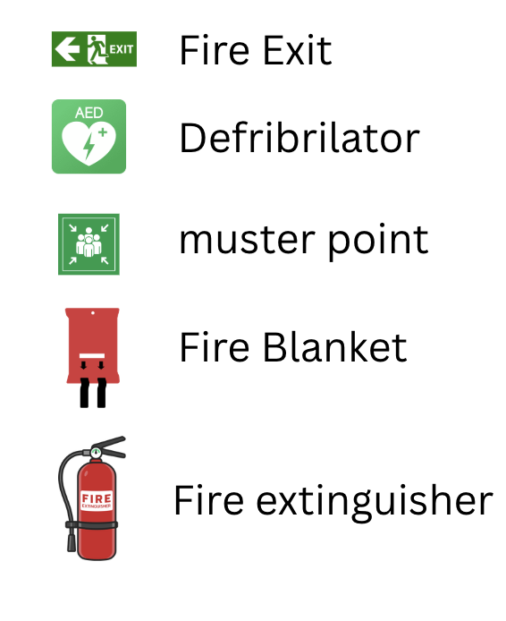

• The muster point in the main car park. The Hirer should conduct a headcount and advise emergency services of any absences.
• Checking all escape routes and doors are clear of obstruction and
combustibles.
• Limitation on numbers of people

Explosives and Flammable Substances:
The Hirer shall ensure that:
a) Highly flammable substances are not brought into, or used in any
part of the premises.
b) No internal decorations of a combustible nature (e.g. polystyrene,
cotton wool) shall be erected on or used in the premises without the consent of the Management Committee. No decorations are to be put up near light fittings or heaters.
c) The use of candles, or any other naked flame, is prohibited

At the start of the event or function you should notify all those present about:
• The non-smoking policy
• The fire escape routes and doors which must be kept clear at all
times and immediately available for public exit.
• Who is supervising and how to identify them.
• The location of muster points.
• Taking only valuables immediately to hand and not to try to collect
other belongings elsewhere in the building.

Electrical Appliance Safety:
The Hirer shall ensure that any electrical appliances brought by them to the premises and used there shall be safe, in good working order, and used in a safe manner.

Accidents and Dangerous Occurrences:
The Hirer must report all accidents involving injury to the public to a member of the Village Hall Management Committee as soon as possible and complete the relevant section in the Village Hall’s accident book which is kept in the kitchen. Any failure of equipment belonging to the Village Hall or brought in by the Hirer must also be reported as soon as possible. Certain types of accident or injury must be reported on a special form to the local authority. The Lettings Secretary will advise and give assistance in completing this form.

Health and Hygiene:
Please note that anyone else preparing, serving or selling food or drink, are responsible for safety and hygiene precautions and shall observe all relevant food health and hygiene legislation and regulations.

Electrical Appliance Safety:
Do ensure that any electrical appliances brought on to the premises are safe, in good working order, and used in a safe manner.

First Aid
The first aid box is in the Kitchen. Defibrillator is wall mounted outside the hall.

Please be reminded that the following items are strictly prohibited

Smoking and Vaping Gaming, Betting and Lotteries
The use of illegal substances The selling of alcohol

Eastchurch Village Hall
Departure Check list
(please leave completed check list in post box when leaving)
Name of Hirer:  Date of Hire: | Please initial in box
Kitchen appliances turned off except Fridge
Tables and chairs put away (please stack chairs as per photo)

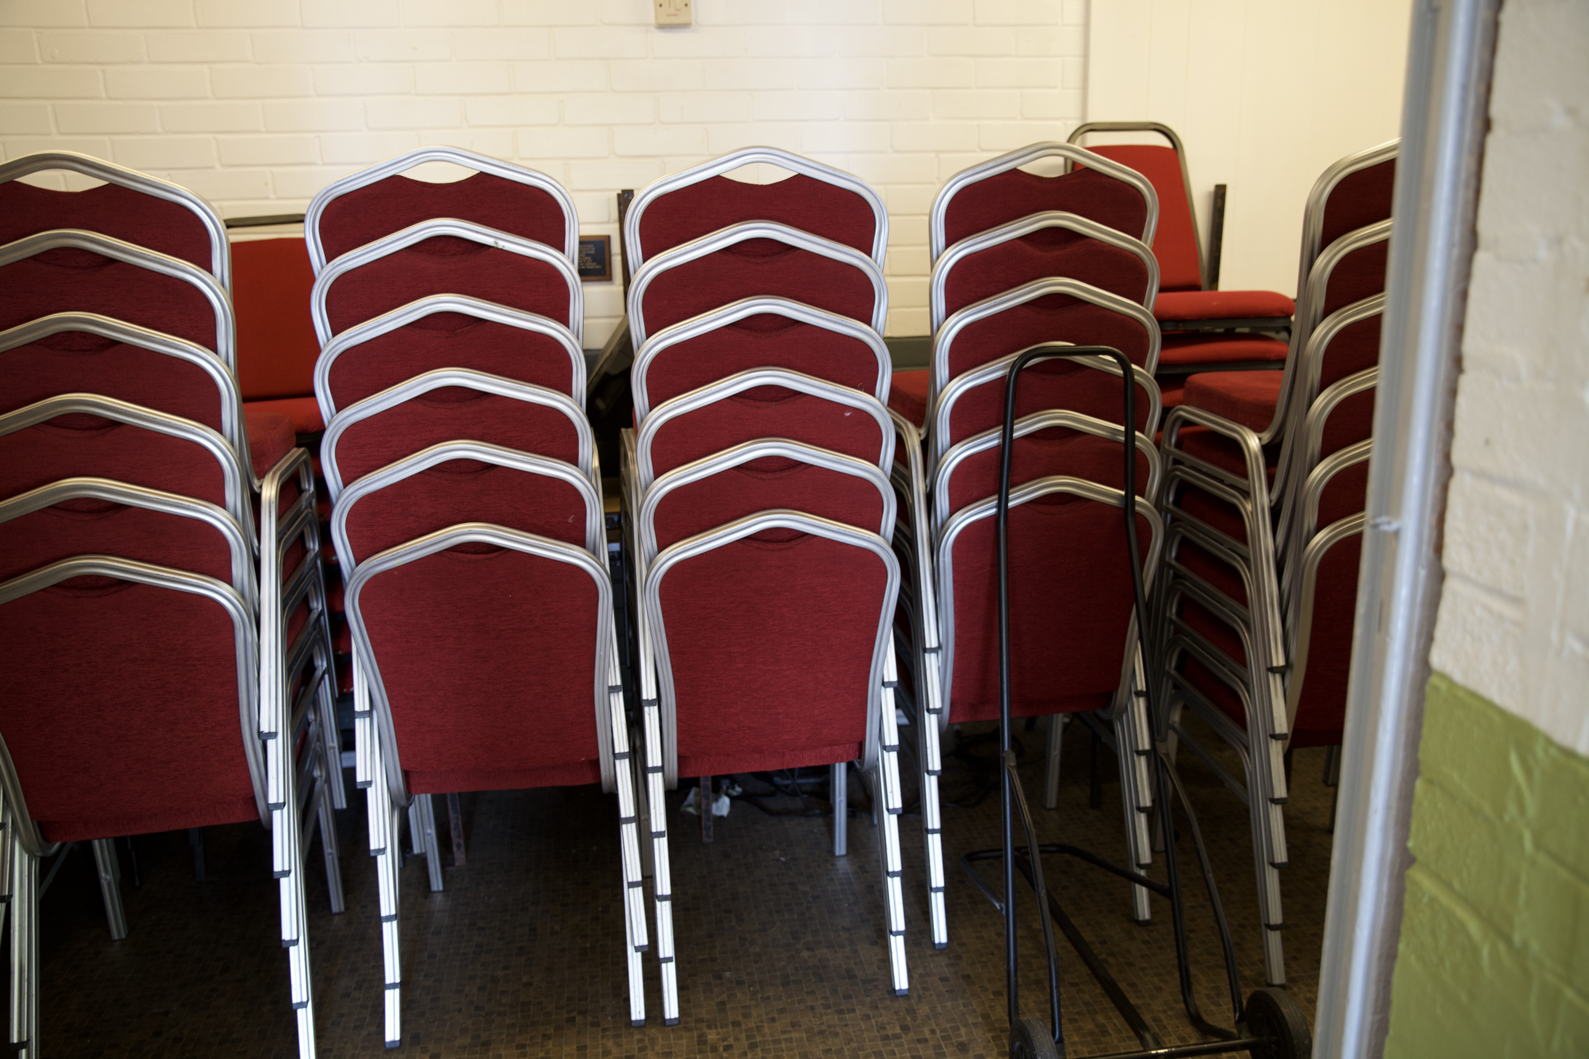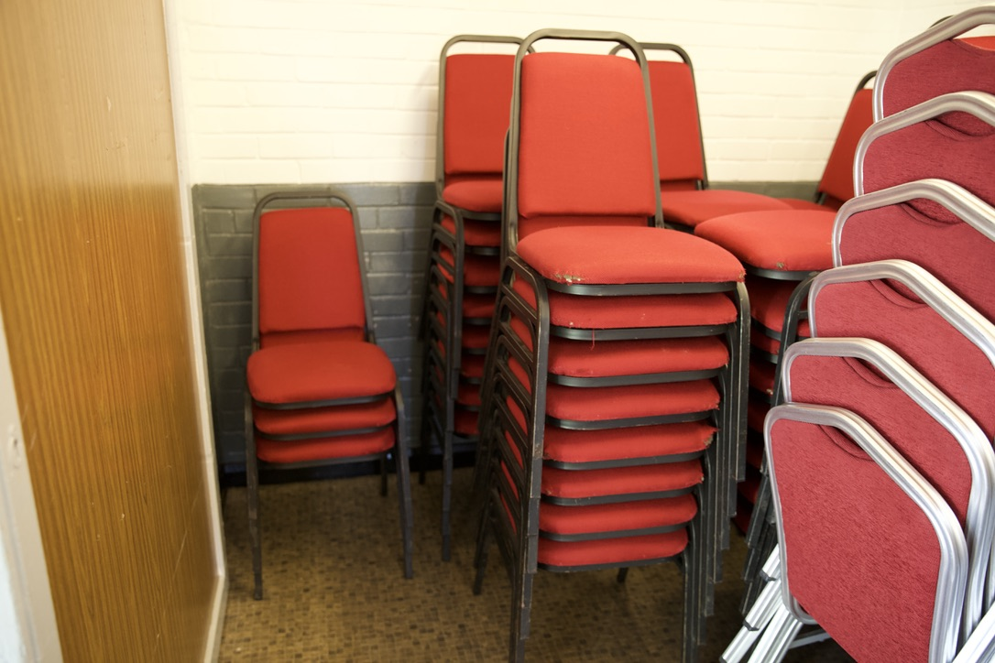
6 high max 8 high max
Floor cleared and swept
Heating switched off
Lights switched off
Windows closed and locked
All belongings removed
Rear doors closed and locked
Toilets are left clean and tidy.
Main door is locked
Please note any issues you wish to bring to our attention

