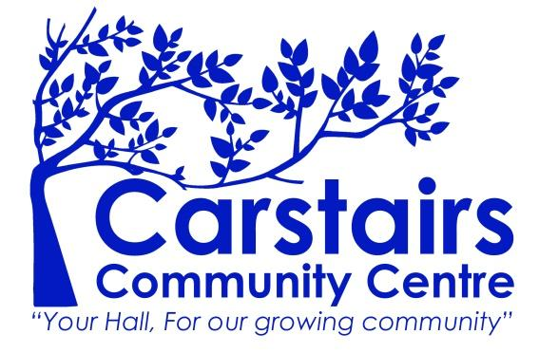

Carstairs Community Centre Management Group SCIO
Complaints Policy
This document aims to help you understand the complaints procedure managed by Carstairs Community Centre Management Board.

What can you complain about?
If you think we have failed to provide a satisfactory standard of service, please let us know.
- Your complaint may be about the quality of the facilities, safety of the users, the handling of a particular situation or issue or any other matter.
- We are committed to equal opportunities and take complaints about discrimination very seriously.

Who will deal with your complaint?
- All complaints should be addressed to the Secretary via email to carstairscommunitycentre@gmail.com who will address the issue and respond in writing.
- If you are not happy with the response, then you will be invited to address your complaint to the whole Board, who will listen to your concerns, consider the issues and whether the follow-up actions were appropriate.
- The Board will then decide on any further actions.
- We will take every complaint seriously and we will treat everyone who complains with respect and courtesy.

When will you hear from us?
We will let you know that we have received your complaint within ten working days. We will write to you or telephone you. In most cases, you will receive a full written response to your complaint within twenty-eight working days.

If we cannot give a full reply in this time, we will write to you and let you know why and how we are dealing with your complaint. If the complaint is complex, we aim to let you have a full reply within two months from date of receipt.

Any safety concerns that would endanger a community centre user would be dealt with immediately after notice is received.

