Entry and Exit Information
Car Park:
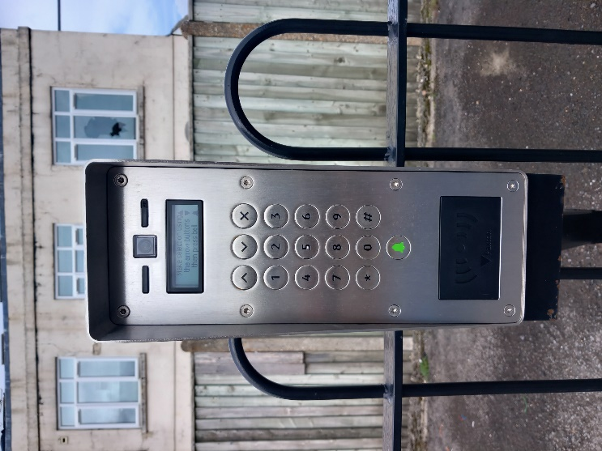
On entry – please pull up in front of the Bollard and enter your code (it will be 5 digits starting with # - eg #1234). The Bollard will drop and the Green Light will appear. Once the Green Light appears – you can drive through to the Car Park.

On Exit – Pull up in front of the bollard, the Bollard will drop automatically, please wait for the Green light to appear before driving through.

Community Centre Building:
Door Entry – please unlock the door using the metal key, then please enter your code (it will be 4 digits – eg 1234) – you will have 7 seconds to open the door. Any internal doors which have a code panel – will be the same process and code for your personal use. If passing through the Hallway into the Courtyard – please put your hand in front of the Green ‘No Touch Door Release’ sensor to the left of the door.
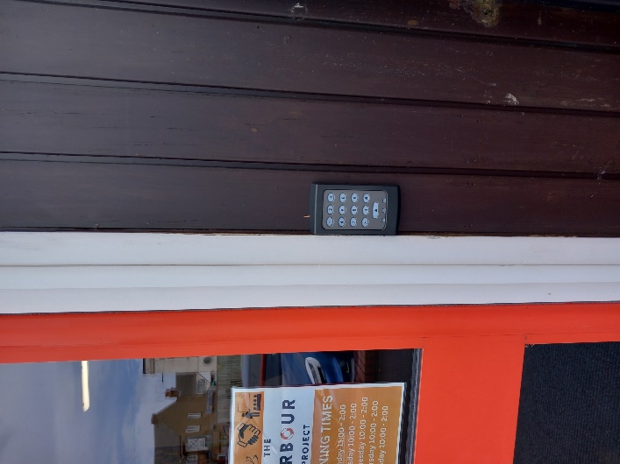

Door Exit – most doors are free to Exit – other than the Main Entrance Door. To exit the Main Entrance Door – please put your hand in front of the ‘No Touch Door Release’ sensor to left of the Door. Once through – the door will close automatically behind you. If you are the event organiser – please check that the door has locked behind you and use the metal key to lock it.
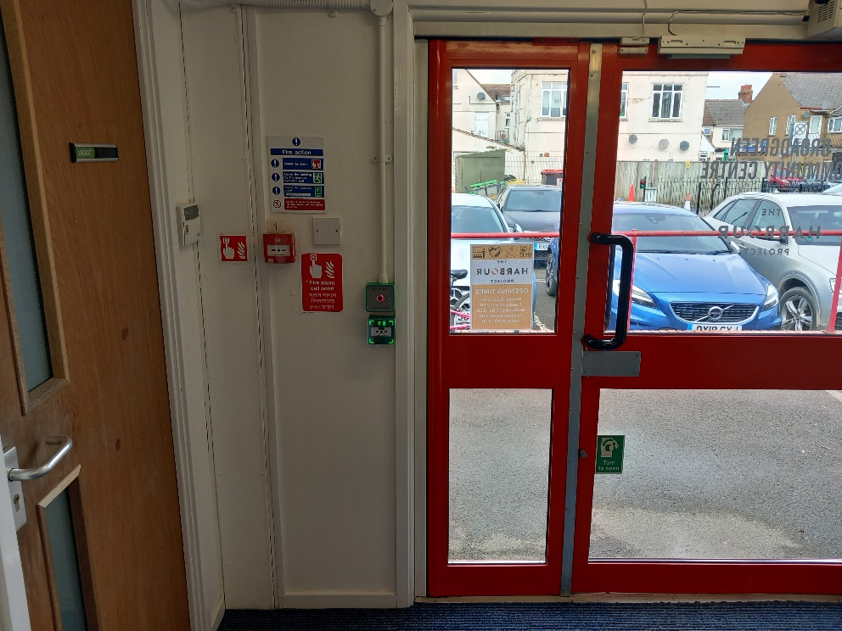

All codes will be given to the event Hirer prior to the booking and will only be operation during the booking time and date.

Please make your guests aware of these codes and processes.

Alarm:
If you have been given a key fob or code to disarm/reset the alarm:
The alarm panel is on the wall to the right as you step inside the front entrance door.
When first entering: Present the key fob to the panel or type in the code, and it will disarm the system.
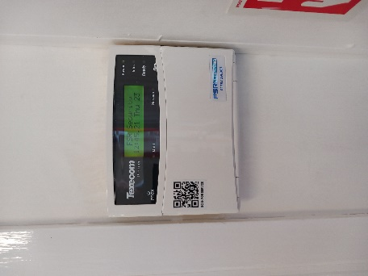
On exit: present the key fob to the panel or type in the code, a message will then ask you if you wish to arm the system. Flip down the control panel flap – and press yes. Flip up the control panel flap and exit the building.

If you feel that you have any concerns – please contact the Community Facilities Officer prior to the event, to ensure that you are able to access the facilities.

